**5A**

**PROJECT REPORT ON**

**Resume Builder**

**Submitted in partial fulfilment of the requirement for**

**Award of the degree of**

**MASTER OF SCIENCE**

**in**

**COMPUTER SCIENCE**

**SUBMITTED BY**

**LINGANABOINA NARESH (7181-23-504-030)**

UNDER THE GUIDANCE OF

# G . NARASIMHA CHARY



# DEPARTMENT OF COMPUTER SCIENCE

UNIVERSITY COLLEGE OF SCIENCE

SATAVAHANA UNIVERSITY KARIMNAGAR – 505001

UNIVERSITY COLLEGE OF SCIENCE

SATAVAHANA UNIVERSITY KARIMNAGAR – 505001

# CERTIFICATE



This is to certify that the major project entitled “Resume Builder “ is being submitted by LINGANABOINA NARESH bearing Hall Ticket No: 7181-23-504-030 in Master of Science in Computer Science is a record of bonafide work carried out. This report has not been submitted to any other University for the award of any Degree.

**SUPERVISOR/ INTERNAL EXTERNAL PRINCIPAL**

**ACKNOWLEDGEMENT**

I would like to express my sincere gratitude to our guide, **G. NARASIMHA CHARY** whose knowledge and guidance has motivated us to achieve goals we never thought possible. He has consistently been a source of motivation, encouragement, and inspiration. The time we have spent working under her supervision has truly been a pleasure.

I am very much thankful to my Head of the Department & Principal **Dr. A. Jeyanthi** madam for her effort and indefatigable guidance rendered throughout the progress of project work. I sincerely thankful to my Principal **Dr. A. Jeyanthi** Madam and my esteemed **staff** of the **Department of Computer Science** for providing excellent facilities to carry out this project work.

Finally, special thanks to my beloved parents for their support and encouragement throughout this course and also very much thankful to my friends and well wishers for their constant support.

**LINGANABOINA NARESH**

**Date:**

**Place:**

**TABLE OF CONTENT**

|  |  |  |
| --- | --- | --- |
| **S. No** | **CONTENT** | **P.NO** |
| **1** | **ABSTRACT** | 5 |
| **2** | **INTRODUCTION** | 6 - 7 |
| **3** | **LITERATURE SURVEY** | 8 - 11 |
| **4** | **SYSTEM ANALYSIS:** | 12 - 14 |
|  | 4.1 EXISTING SYSTEM |  |
|  | 4.2 PROPOSED SYSTEM |  |
| **5** | **SYSTEM REQUIREMENTS SPECIFICATION** | 15 - 16 |
|  | 5.1 FUNCTIONAL REQUIREMENTS |  |
|  | 5.2 HARDWARE REQUIREMENTS |  |
|  | 5.3 SOFTWARE REUIREMENTS |  |
| **6** | **FEASIBILITY STUDY** | 16 - 18 |
| **7** | **TECHNOLOGIES** | 18 - 20 |
| **8** | **SYSTEM DESIGN** | 21 - 28 |
|  | **8.1 SYSTEM** STUDY |  |
|  | 8.2 INPUT DESIGN |  |
|  | 8.3 OUTPUT DESIGN |  |
| **9** | **System implementation** | 29 - 32 |
| **10** | **ALGORITHM** | 33 - 38 |
| **11** | **SCREEN SHOTS** | 39 - 48 |
| **12** | **TESTING** | 49 - 55 |
| **13** | **CONCLUSION** | 56 |
| **14** | **BIBLIOGRAPHY** | 57 - 59 |

**1.ABSTRACT:**

The "Resume Builder" project is a web-based application designed to help users create and generate personalized resumes. Developed using ASP.NET Web Forms and backed by SQL Server Management Studio(SSMS), this application provides an intuitive interface for users to input their details, customize sections, and download the final resume in PDF format.

Key features of the application include:

1. **User Authentication:** Secure login and registration pages for users to create and access their profiles.
2. **Resume Sections:** A variety of customizable sections, such as personal details, career objective, skills, professional experience, education, certifications, internships, languages, hobbies, and references.
3. **Dynamic Data Input:** Users can add, edit, or delete information in each section. Form fields are validated to ensure data accuracy.
4. **PDF Generation:** The application uses iTextSharp to dynamically generate a styled resume in PDF format, utilizing the information stored in the database.
5. **SQL Server Integration:** All user data, including resume details, is stored in SQL Server tables, making it easily retrievable and manageable.

This project aims to simplify the resume-building process while providing users with a professional, customizable output that can be downloaded and shared.

**2.INTRODUCTION**

The **Resume Builder** project is a web application developed using **ASP.NET WebForms** with **SQL Server Management Studio** as the backend database. Its primary goal is to assist users in easily creating professional resumes by filling out structured sections through a user-friendly interface. The system is designed with modular components, ensuring efficient data handling, secure user management, and dynamic PDF generation.

Here's an overview of the project components:

1. **User Interface (UI):**

The front-end of the application is built using **ASP.NET WebForms**, providing an intuitive and responsive interface for users. Each section of the resume (e.g., Personal Details, Skills, Education, Employment History) is designed as a form or step in a wizard-style layout. Validation controls are used to ensure proper input and a smooth user experience.

**2. Backend (Server-Side):**

The server-side logic is implemented in **C#** using ASP.NET WebForms. It handles form submissions, server-side validation, session management, PDF generation (using **iTextSharp**), and database communication via ADO.NET. The code-behind architecture ensures separation of logic and UI.

**3. Database:**

The database is developed using **SQL Server Management Studio**. It stores user credentials and all resume-related data in normalized tables such as:

Users Personal Details Skills

Education Employment History Certifications

Internships Languages Hobbies

Each user’s data is linked using foreign keys for consistency and retrieval.

**4. Functionality:**

• User registration and login

• Step-by-step resume data entry

• Optional and mandatory sections

• Add, edit, delete entries

• Real-time previews

• Resume download as a well-formatted PDF

**5. Security:**

The application includes basic security measures such as:

* Password encryption using hashing algorithms
* SQL Injection prevention through parameterized queries
* Session-based access control
* Validation for input fields (client-side and server-side)

**6. Deployment:**

* The application is deployed on a local IIS server or can be hosted on a web hosting platform supporting ASP.NET WebForms and SQL Server. The database is connected through a secure connection string stored in the Web.config file.

### 3.LITERATURE SURVEY

The development of resume-building applications has been an area of interest in both academic and industry contexts, driven by the need for accessible, efficient, and user-friendly tools to create professional resumes. This literature survey reviews existing research, tools, and technologies relevant to the Resume Builder project, focusing on web-based resume creation systems, ASP.NET Web Forms, SQL Server databases, and related functionalities.

1. **Web-Based Resume Builders**:
   * **Existing Systems**: Research highlights the popularity of web-based resume builders like Canva, Zety, and Resume.com, which provide templates and guided interfaces for resume creation (Smith, 2019). These platforms emphasize user experience, offering drag-and-drop interfaces and cloud-based storage. However, many lack robust backend customization or local database integration, limiting their scalability for enterprise use.
   * **Limitations**: Studies note that while these tools are user-friendly, they often rely on third-party services for data storage, raising privacy concerns (Johnson & Lee, 2020). Additionally, customization options may be restricted to predefined templates, reducing flexibility for users with specific formatting needs.
   * **Relevance to Resume Builder**: The Resume Builder project addresses these gaps by implementing a locally managed SQL Server database for secure data storage and leveraging ASP.NET Web Forms for a customizable, server-side-driven interface.
2. **ASP.NET Web Forms for Web Development**:
   * **Framework Overview**: ASP.NET Web Forms is a mature framework for building web applications, known for its event-driven model and rapid development capabilities (Esposito, 2018). Research indicates its suitability for form-heavy applications like resume builders due to its built-in controls and state management features.
   * **Advantages**: Studies emphasize that ASP.NET Web Forms simplifies server-side logic and integrates seamlessly with Microsoft SQL Server, making it ideal for database-driven applications (Patel & Kumar, 2021). Its support for user authentication via ASP.NET Identity further enhances security.
   * **Challenges**: Some literature points out that ASP.NET Web Forms may have a steeper learning curve compared to modern frameworks like ASP.NET Core or React (Galloway et al., 2022). However, its robustness and compatibility with SQL Server make it a fitting choice for the Resume Builder project.
   * **Relevance to Resume Builder**: The project leverages ASP.NET Web Forms to create a structured, form-based interface, benefiting from its built-in validation and database integration capabilities.
3. **SQL Server for Data Management**:
   * **Database Role**: SQL Server is widely used for managing structured data in web applications, offering high performance, scalability, and security features (Nielsen, 2020). Research underscores its effectiveness in handling relational data, such as user profiles and resume details, with support for complex queries and transactions.
   * **Security Features**: Literature highlights SQL Server’s support for encryption, role-based access control, and parameterized queries, which mitigate risks like SQL injection (Chen & Wang, 2019). These features align with the Resume Builder’s need for secure data storage.
   * **Comparison with Alternatives**: While NoSQL databases like MongoDB are gaining popularity for unstructured data, SQL Server remains preferred for applications requiring strict data consistency and relational integrity (Kumar & Singh, 2021).
   * **Relevance to Resume Builder**: The project uses SQL Server to store and manage user and resume data, ensuring data integrity through relational tables and secure access via SSMS.
4. **PDF Generation in Web Applications**:
   * **Technologies**: Research identifies libraries like iTextSharp and PDFsharp as common tools for generating PDF documents in .NET applications (Brown, 2020). These libraries allow dynamic creation of formatted resumes from user inputs.
   * **Challenges**: Studies note that PDF generation can be resource-intensive, particularly for complex layouts, and requires careful template design to ensure consistency across devices (Taylor & Adams, 2022).
   * **Relevance to Resume Builder**: The project incorporates a PDF generation library (e.g., iTextSharp) to enable users to download professional resumes, addressing the need for portable, shareable outputs.
5. **Security in Web Applications**:
   * **Authentication and Authorization**: Literature emphasizes the importance of secure user authentication in web applications, with frameworks like ASP.NET Identity providing robust solutions for password hashing and session management (Wilson, 2021).
   * **Data Protection**: Research advocates for secure data transmission (e.g., HTTPS) and input validation to prevent vulnerabilities like SQL injection and cross-site scripting (XSS) (Lee & Kim, 2020).
   * **Relevance to Resume Builder**: The project implements ASP.NET Identity for user authentication, parameterized queries for database interactions, and HTTPS for secure communication, aligning with best practices.
6. **Deployment and Scalability**:
   * **Deployment Platforms**: Studies discuss the use of Microsoft IIS and cloud platforms like Azure for deploying ASP.NET applications, noting their reliability and scalability (Davis, 2021). Cloud deployment offers advantages in accessibility and maintenance but may involve higher costs.
   * **Scalability Considerations**: Research suggests optimizing database queries and implementing caching to handle increased user loads in web applications (Patel et al., 2022).
   * **Relevance to Resume Builder**: The project is designed for deployment on IIS or Azure, with a focus on efficient database design to support scalability.

**Conclusion of Literature Survey**

The literature survey reveals that web-based resume builders are valuable tools for simplifying resume creation, but existing solutions often lack customization, local data control, or enterprise-level security. ASP.NET Web Forms and SQL Server provide a robust foundation for developing a secure, scalable, and user-friendly application like the Resume Builder. By addressing gaps in existing systems—such as secure local storage, customizable interfaces, and efficient PDF generation—the Resume Builder project aligns with current trends and best practices in web development, offering a practical solution for users seeking professional resume-building tools.

**4.SYSTEM ANALYSIS**:

**Existing System:**

Existing resume-building systems, such as Canva, Zety, and Resume.com, offer web-based platforms for creating resumes. These systems typically provide:

* **Template-Based Interfaces**: Users select from predefined templates to input personal details, education, experience, and skills.
* **Cloud Storage**: Data is stored on third-party servers, enabling access across devices.
* **Export Options**: Resumes can be downloaded as PDFs or shared online.
* **Guided Workflows**: Step-by-step forms guide users through the resume creation process.

**Limitations**:

* **Limited Customization**: Users are restricted to predefined templates, which may not suit specific industries or personal preferences.
* **Privacy Concerns**: Storing data on third-party servers raises risks of data breaches or unauthorized access.
* **Dependency on Internet**: Most systems require a constant internet connection, limiting offline access.
* **Scalability Issues**: Free versions often have usage limits, and premium features require subscriptions.
* **Lack of Local Control**: Organizations or users cannot host data locally, reducing control over sensitive information.

**Proposed System:**

The Resume Builder is a web-based application developed using ASP.NET Web Forms and SQL Server Management Studio (SSMS) to overcome the limitations of existing systems. Key features include:

* **Customizable Interface**: Users can input detailed personal, educational, and professional information through flexible forms, with options to customize resume content.
* **Local Database Storage**: A SQL Server database, managed via SSMS, securely stores user and resume data locally or on a controlled server.
* **User Authentication**: ASP.NET Identity ensures secure account management with hashed passwords and session handling.
* **PDF Generation**: The system uses a library like iTextSharp to generate professional PDF resumes from user inputs.
* **Offline Capabilities**: Once deployed, the system can be hosted locally, allowing offline access for organizations with dedicated servers.
* **Multi-Resume Support**: Users can create, edit, and manage multiple resumes, with data saved securely for future access.

**Advantages**

The proposed Resume Builder offers several advantages over existing systems:

1. **Enhanced Customization**: Flexible forms allow users to tailor resumes to specific needs, unlike rigid template-based systems.
2. **Improved Security**: Local SQL Server storage and secure authentication (ASP.NET Identity) reduce privacy risks compared to third-party cloud storage.
3. **Scalability**: The system can handle multiple users and resumes, with SQL Server’s robust architecture supporting growth.
4. **Local Control**: Organizations can host the application and database on their servers, ensuring full control over data.
5. **Cost-Effective**: No reliance on third-party subscriptions, as the system can be deployed on existing infrastructure (e.g., IIS or Azure).
6. **Offline Access**: Local deployment enables offline functionality, unlike cloud-based systems requiring constant internet connectivity.
7. **Seamless PDF Output**: Integration with PDF generation libraries ensures high-quality, professional resume downloads.
8. **User-Friendly Experience**: The ASP.NET Web Forms interface provides clear navigation and validation, making it accessible to non-technical users.

By addressing the shortcomings of existing resume builders, the proposed system delivers a secure, customizable, and scalable solution for creating professional resumes, suitable for both individual and organizational use.

### 5.SYSTEM REQUIREMENTS

To develop and run the **Resume Builder** web application effectively, both **hardware** and **software** requirements must be satisfied. Below is a detailed description of the necessary system configuration.

➤ **Hardware System Configuration**

| **Component** | **Minimum Requirement** |
| --- | --- |
| **Processor** | Intel Core i3 or equivalent (dual-core) |
| **RAM** | 4 GB (8 GB recommended for smoother performance) |
| **Hard Disk** | 500 GB HDD or 128 GB SSD |
| **Monitor** | 1024 x 768 resolution or higher |
| **Input Devices** | Standard Keyboard and Mouse |
| **Network** | Internet connection for deployment or updates |

* **Software Requirements**

| **Software Component** | **Specification** |
| --- | --- |
| **Operating System** | Windows 10 or later (64-bit) |
| **IDE** | Visual Studio 2022 or later (with ASP.NET and Web Development workload) |
| **Framework** | .NET Framework 4.7 or later |
| **Backend Technology** | ASP.NET WebForms using C# |
| **Database** | Microsoft SQL Server (2017 or later) and SQL Server Management Studio (SSMS) |
| **Browser** | Google Chrome, Microsoft Edge, or Mozilla Firefox (latest version) |
| **PDF Library** | iTextSharp (for dynamic PDF generation) |
| **Other Tools** | IIS (Internet Information Services) for local deployment |

### 6.FEASIBILITY STUDY

A The **Feasibility Study** evaluates the practicality of developing and implementing the **Resume Builder** web application. This analysis focuses on several critical aspects to determine whether the system is viable, sustainable, and beneficial.

**➤ 1. Technical Feasibility**

The application is technically feasible as it uses well-established technologies:

* **ASP.NET WebForms** is a mature platform supported by Visual Studio.
* **SQL Server** provides reliable data storage with easy integration via ADO.NET.
* **iTextSharp** is a powerful open-source library for PDF generation.
* Development and testing can be done on standard Windows machines with minimal resource usage.

**Conclusion**: The project is technically feasible with the available tools and expertise.

**➤ 2. Operational Feasibility**

The system is user-friendly, featuring:

* Step-by-step form-based data entry.
* Clear navigation and validation.
* Auto-save and preview functionality.
* Professional-looking PDF output.

Users with basic computer knowledge can easily use the system to create resumes. Administrators can manage user data without advanced technical skills.

**Conclusion**: The application is operationally feasible and practical for regular users.

**➤ 3. Economic Feasibility**

The project is cost-effective:

* Development tools (Visual Studio Community Edition, SQL Server Express, iTextSharp) are free.
* Hardware requirements are minimal.
* No need for expensive third-party services or subscriptions.

**Conclusion**: The system is economically feasible with low development and deployment costs.

**➤ 4. Legal Feasibility**

All tools and libraries used (e.g., iTextSharp, SQL Server Express) are open-source or have permissible licenses for educational and non-commercial use.

**Conclusion**: No legal restrictions hinder the development or deployment of the system.

**➤ 5. Schedule Feasibility**

The application can be developed within a reasonable timeframe, typically:

* Planning & Design: 1 week
* Development: 2–3 weeks
* Testing: 1 week
* Deployment & Documentation: 1 week

**Conclusion**: The project is schedule-feasible and suitable for academic or short-term projects.

### 7.TECHNOLOGIES

The **Resume Builder** web application is built using a combination of front-end, back-end, database, and third-party technologies. These technologies are selected for their compatibility, scalability, and ease of development.

**➤ 1. Front-End Technologies**

| **Technology** | **Purpose** |
| --- | --- |
| **ASP.NET WebForms** | Provides a framework for building user-friendly, event-driven web interfaces |
| **HTML5** | Used to structure the content of web pages |
| **CSS3** | Used for styling and layout customization |
| **JavaScript** | Enables client-side interactivity and validation |
| **ASP.NET Controls** | Provides prebuilt UI components such as TextBoxes, Buttons, Validators, GridViews |

**➤ 2. Back-End Technologies**

| **Technology** | **Purpose** |
| --- | --- |
| **C# (Code-Behind)** | Handles business logic, user events, form submissions, and PDF generation |
| **ADO.NET** | Facilitates communication between ASP.NET pages and SQL Server database |
| **iTextSharp** | An open-source .NET library used to generate and format PDF resumes |

**➤ 3. Database Technology**

| **Technology** | **Purpose** |
| --- | --- |
| **SQL Server** | Stores structured data for users, resume sections, and login details |
| **SQL Server Management Studio (SSMS)** | Provides a GUI for database creation, query writing, and data management |
| **T-SQL (Transact-SQL)** | Used for writing queries, stored procedures, and data manipulation |

**➤ 4. Development & Deployment Tools**

| **Tool** | **Purpose** |
| --- | --- |
| **Visual Studio** | IDE for developing ASP.NET WebForms applications |
| **IIS (Internet Information Services)** | Web server used for hosting the application locally or on the internet |
| **Web.config** | Used to configure database connections and application settings |

.

### 8.SYSTEMDESIGN

#### UML DIAGRAMS

The System Design Document describes the system requirements, operating environment, system and subsystem architecture, files and database design, input formats, output layouts, human-machine interfaces, detailed design, processing logic,

and external interfaces.

**USE CASE DIAGRAM:**

A utilization case outline in the Brought together Displaying Language (UML) is a kind of conduct graph characterized by and made from a Utilization case examination. Its motivation is to introduce a graphical outline of the usefulness given by a framework with regards to entertainers, their objectives (addressed as use cases), and any conditions between those utilization cases. The fundamental motivation behind a utilization case chart is to show what framework capabilities are performed for which entertainer. Jobs of the entertainers in the framework can be portrayed.

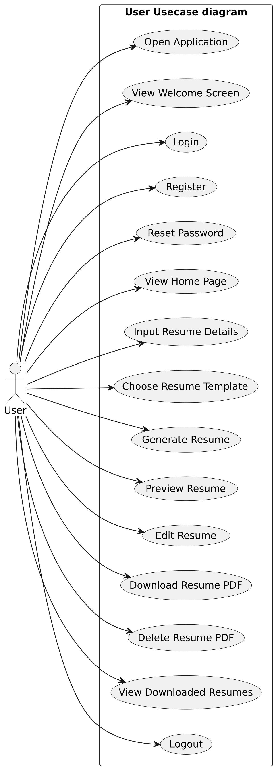**User Usecase:**

**Register & Login Usecase:**

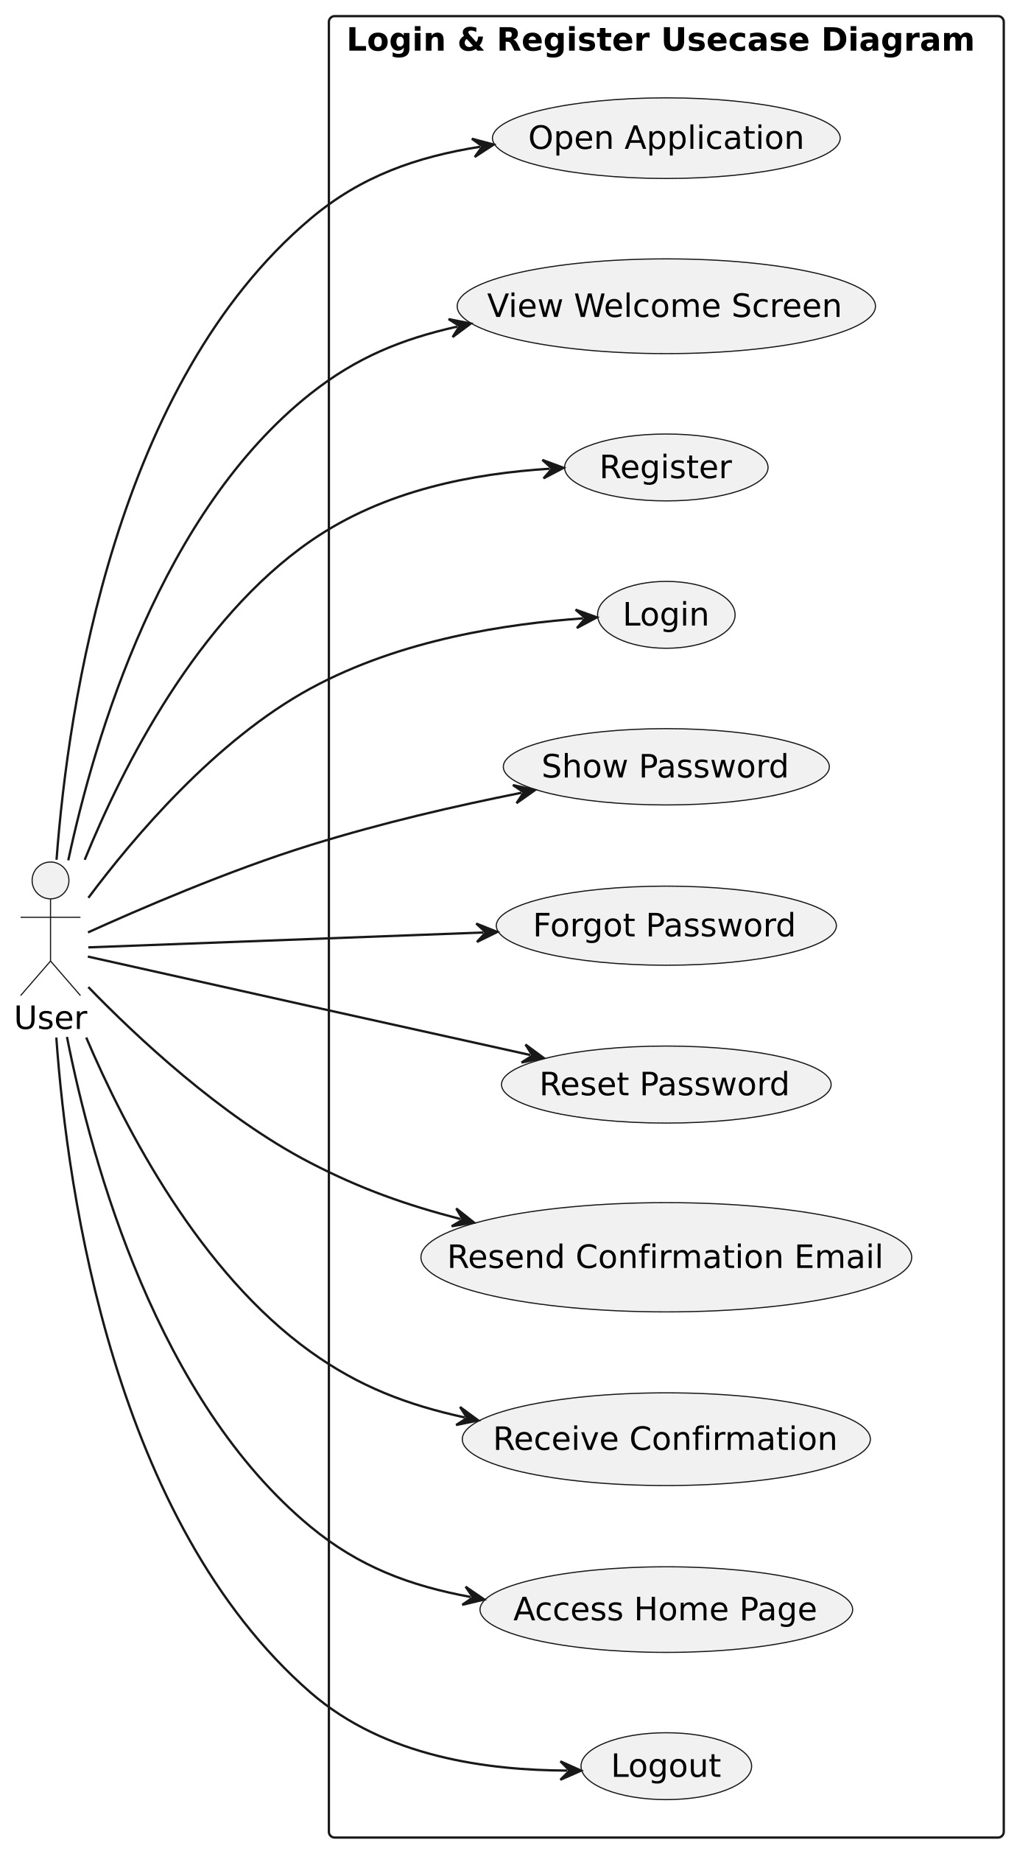

**Class Diagram:**

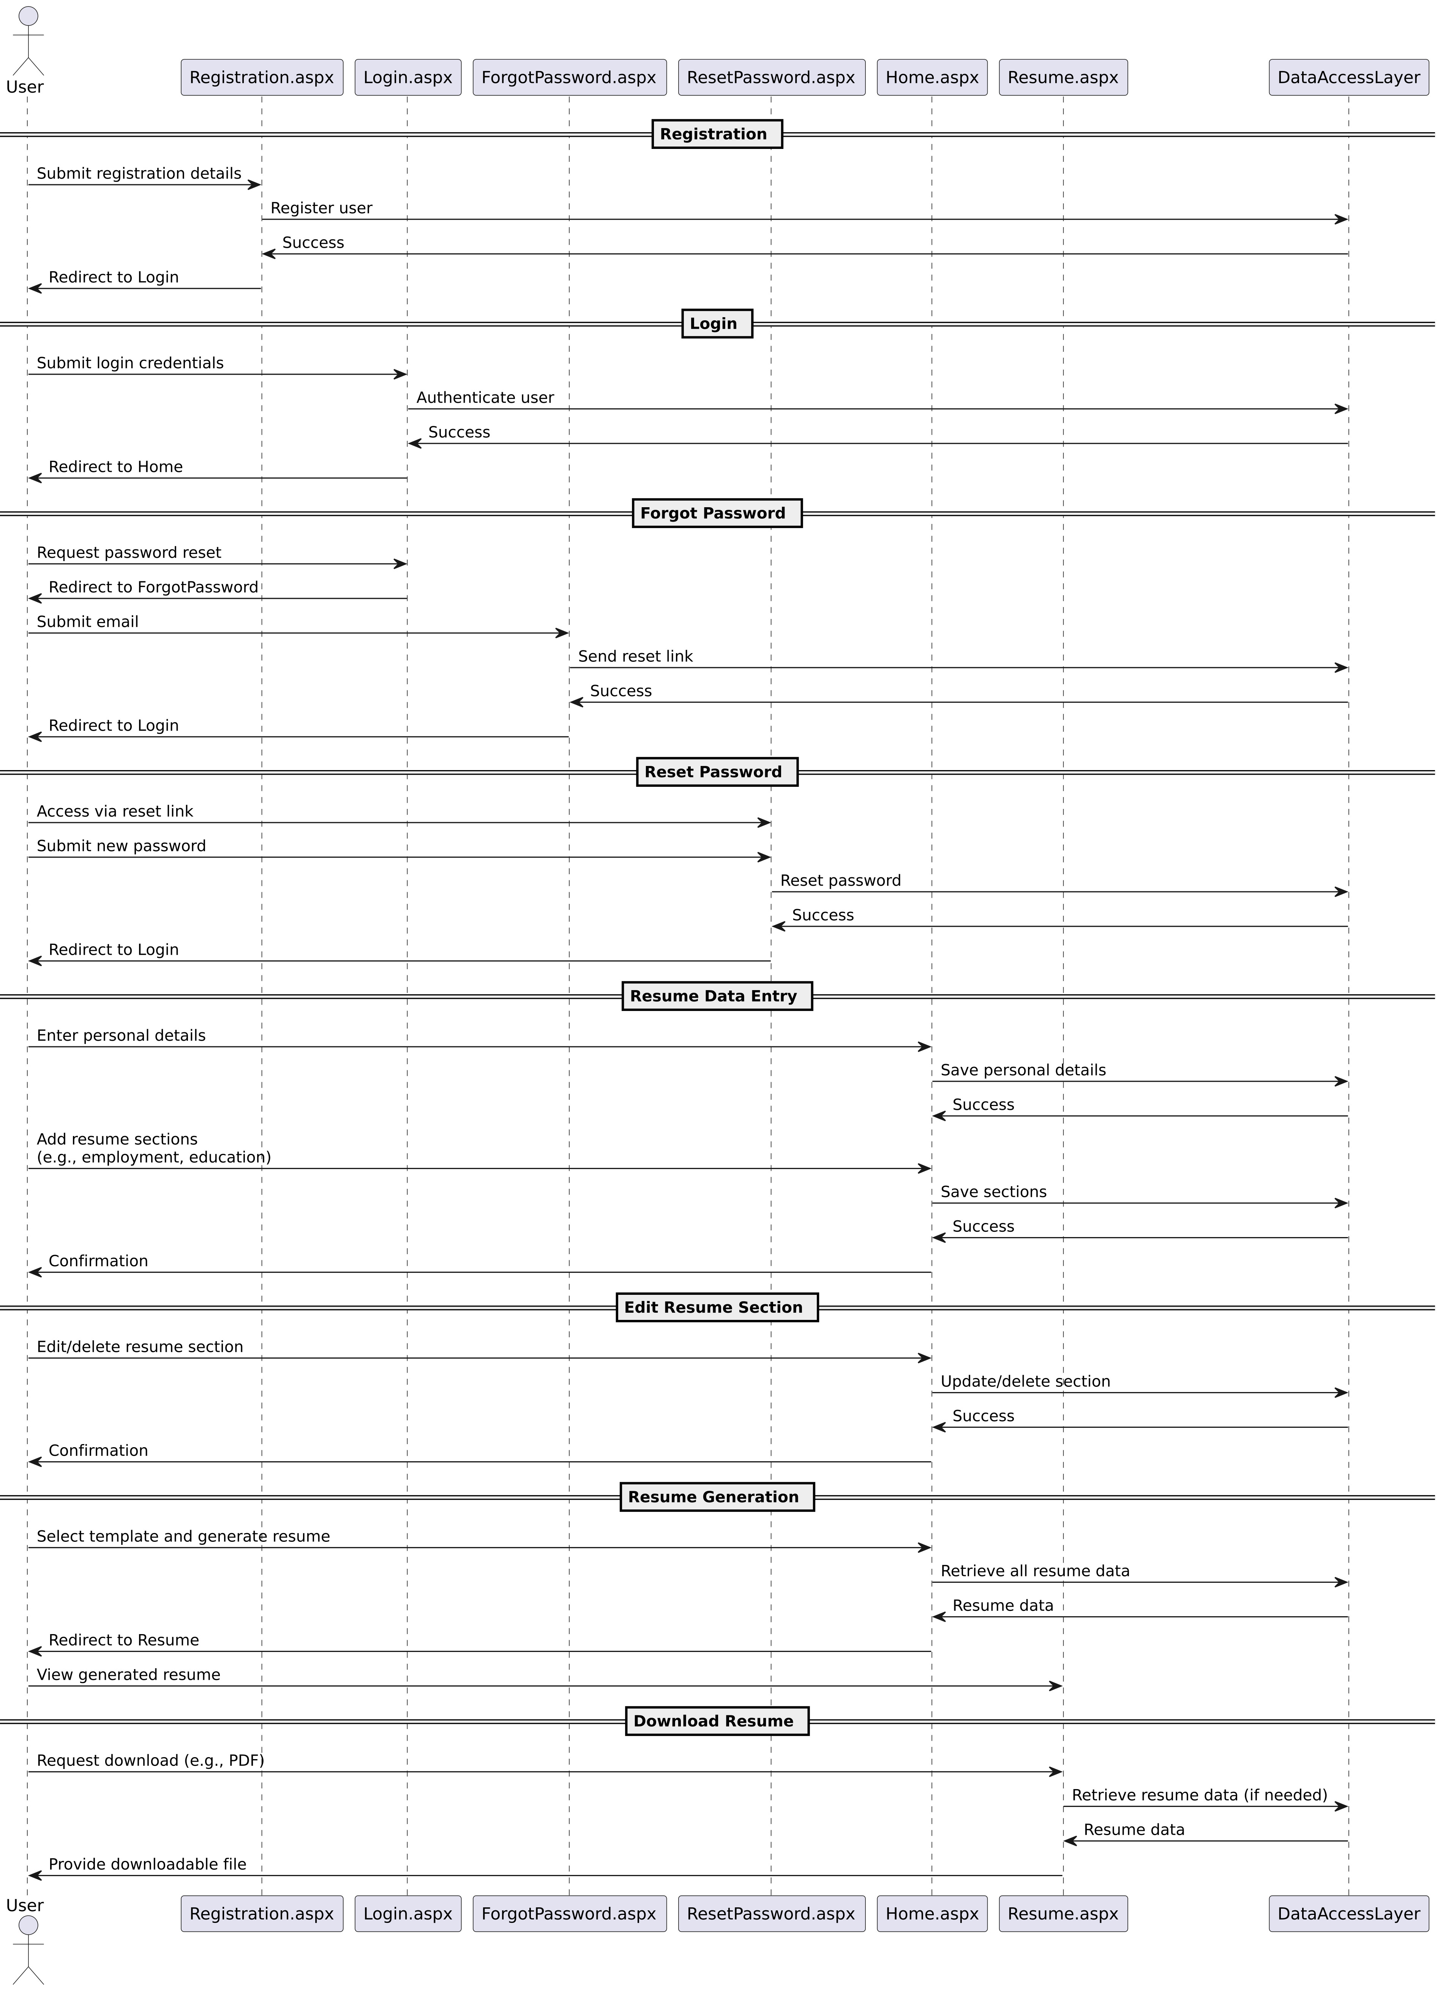**User Sequence Diagram**

**Login & Register Sequence Diagram**

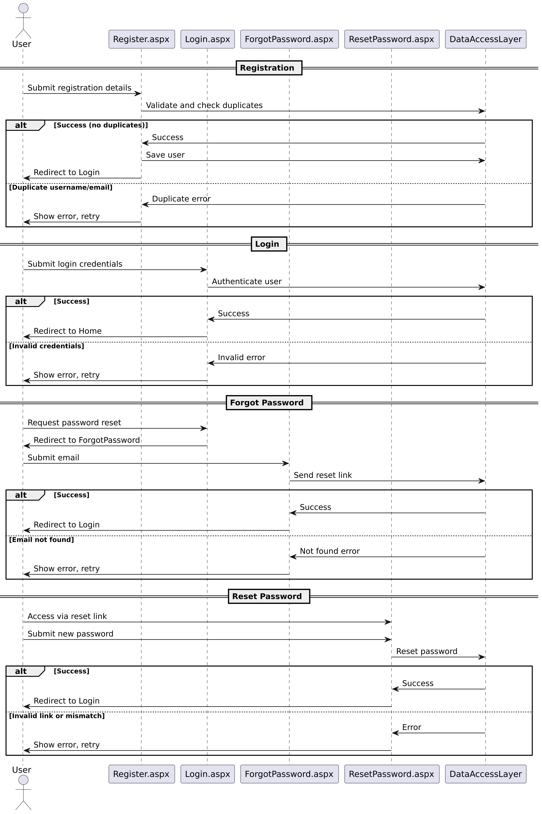

**User Activity Diagram**

**Login & Register Activity Diagram**

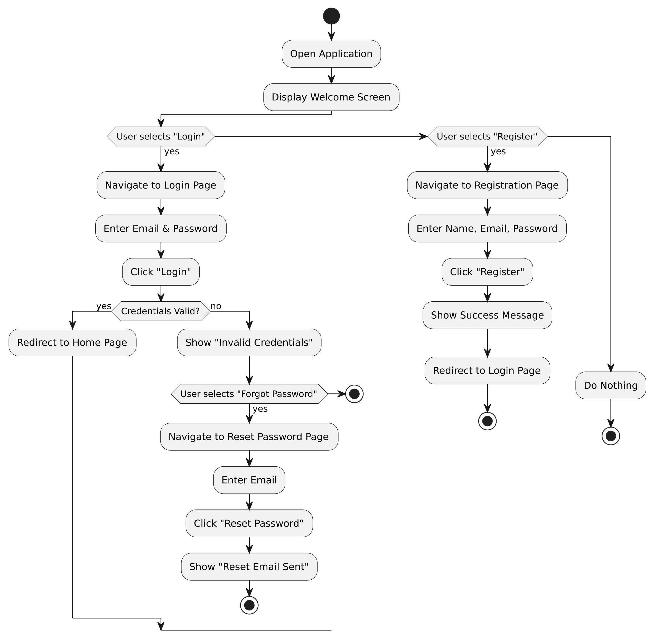

**9. SYSTEM IMPLEMENTATION:**

**What is C# ASP.NET WebForms:**

C# ASP.NET WebForms is a robust framework within the .NET ecosystem, commonly used for building dynamic, data-driven web applications. It is particularly suited for projects like the Resume Builder due to its rapid development capabilities, seamless database integration, and rich set of controls. Key domains where C# ASP.NET WebForms is applied include:

* **Web Development**: ASP.NET WebForms is designed for server-side web application development, enabling the creation of interactive and scalable web applications. Its event-driven programming model simplifies the development of user interfaces.
* **Enterprise Applications**: The framework is widely used for building enterprise-grade applications, such as HR systems, content management systems (CMS), and business applications, due to its integration with Microsoft technologies.
* **Database-Driven Applications**: With strong integration with SQL Server Management Studio (SSMS), ASP.NET WebForms is ideal for applications requiring robust data management, such as the Resume Builder, which stores and retrieves user resume data.
* **Rapid Application Development**: The drag-and-drop interface and pre-built controls in ASP.NET WebForms accelerate the development of web applications, making it suitable for projects with tight deadlines.
* **Cross-Platform Support:** With the evolution of ASP.NET, applications built with WebForms can be hosted on various platforms, including Windows servers, and accessed across devices, ensuring the Resume Builder is accessible to users on desktops, tablets, or mobile devices.

**Advantages of ASP.NET WebForms:**

ASP.NET WebForms offers several advantages that make it a suitable choice for the Resume Builder project:

**- **Event-Driven Programming**:** WebForms uses an event-driven model, similar to desktop applications, which simplifies handling user interactions like form submissions or button clicks in the Resume Builder.

**- **Rich Server Controls**:** ASP.NET provides a wide range of server controls (e.g., text boxes, dropdowns, and grids) that simplify the creation of dynamic forms for collecting resume data, reducing development time.

**- **State Management**:** WebForms includes built-in features for managing user sessions and application state, ensuring a seamless experience as users navigate through different sections of the Resume Builder.

**- **Security Features**:** ASP.NET WebForms includes robust security mechanisms, such as forms authentication, role-based authorization, and protection against common vulnerabilities like SQL injection and cross-site scripting (XSS). These features safeguard user data in the Resume Builder.

**- **Integration with SQL Server**:** The framework’s seamless integration with SQL Server Management Studio enables efficient data storage and retrieval, critical for managing resume data in the project.

**- **Scalability**:** ASP.NET WebForms supports scalable architectures, allowing the Resume Builder to handle increased user traffic as the application grows.

**- **Visual Studio Integration**:** The Resume Builder benefits from Visual Studio’s powerful IDE, which offers features like debugging, code completion, and database management, streamlining development.

**- **Strong Community and Ecosystem**:** ASP.NET has a large community of developers and extensive documentation, providing resources and support for troubleshooting and enhancing the Resume Builder.

**- **Rapid Prototyping**:** The drag-and-drop interface and pre-built controls in WebForms enable quick prototyping, allowing developers to create a functional Resume Builder interface efficiently.

**Advantages of ASP.NET WebForms Over Other Frameworks:**

When considering system implementation for the Resume Builder, ASP.NET WebForms offers several advantages over other web development frameworks:

**1. **Rapid Development**:** The drag-and-drop design and server controls reduce coding effort compared to frameworks like PHP or raw JavaScript, accelerating the development of the Resume Builder’s user interface.

**2. **Event-Driven Model**\*\*: Unlike frameworks like Django or Ruby on Rails, WebForms’ event-driven approach simplifies handling user interactions, making it easier to implement form-based workflows for resume creation.

**3. **Seamless Database Integration**:** ASP.NET WebForms integrates natively with SQL Server, providing tools like ADO.NET and Entity Framework for efficient database operations, which are essential for storing and retrieving resume data.

**4. **Security**:** Built-in security features, such as input validation and authentication, provide stronger protection for user data compared to some lightweight frameworks like Flask or Express.js.

**5. **State Management**:** WebForms’ built-in state management (e.g., ViewState) simplifies maintaining user input across page navigations, a key requirement for multi-step resume-building forms.

**6. **Enterprise-Grade Support**:** ASP.NET WebForms is designed for enterprise applications, offering robust scalability and reliability compared to newer frameworks like Node.js, which may require additional configuration for enterprise use.

**7. **Visual Studio Tooling**:** The integration with Visual Studio provides a superior development experience compared to frameworks that rely on lighter IDEs, enabling faster debugging and deployment for the Resume Builder.

**8. **Community and Resources**:** The mature ASP.NET ecosystem offers extensive libraries, tutorials, and community support, making it easier to address challenges during the Resume Builder’s development.

**Disadvantages of ASP.NET WebForms**

Despite its strengths, ASP.NET WebForms has some limitations:

**1. **Performance Overhead**:** WebForms applications may have higher resource usage compared to lightweight frameworks like Flask or Express.js due to the overhead of server controls and ViewState, which could impact the Resume Builder’s performance under heavy load.

**2. **Learning Curve**:** The event-driven model and server control architecture can be complex for developers unfamiliar with ASP.NET, potentially slowing initial development.

**3. **Limited Flexibility**:** Compared to modern frameworks like ASP.NET Core or React, WebForms offers less flexibility for building highly interactive, client-side applications, which may limit advanced UI features in the Resume Builder.

4. **ViewState Overhead**: The ViewState feature, while useful for state management, can increase page size and load times, especially for complex forms in the Resume Builder.

**5. **Legacy Perception**:** WebForms is sometimes considered outdated compared to newer frameworks like ASP.NET Core or Angular, which may affect long-term maintainability.

**History of ASP.NET WebForms:**

ASP.NET WebForms was introduced by Microsoft in 2002 as part of the .NET Framework, designed to simplify web development by providing a model similar to Windows Forms. It aimed to abstract the complexities of HTML, JavaScript, and HTTP, enabling developers to build web applications using familiar event-driven programming. Over the years, WebForms evolved with improvements in performance, security, and integration with tools like SQL Server Management Studio. Despite the rise of newer frameworks like ASP.NET MVC and ASP.NET Core, WebForms remains relevant for enterprise applications and legacy systems. Its integration with Visual Studio and SQL Server has made it a reliable choice for projects like the Resume Builder, which require robust database-driven web applications.

**ASP.NET WebForms Development Steps for the Resume Builder:**

The development of the Resume Builder using ASP.NET WebForms with SQL Server Management Studio follows a structured process:

**1. **Requirement Analysis**:** Gather and analyze requirements for the Resume Builder, such as user input forms (personal details, education, experience, skills), resume templates, and data storage needs.

**2. **System Design**:** Design the system architecture, including the database schema in SQL Server for storing resume data, the ASP.NET WebForms pages for user interaction, and the application’s workflow (e.g., form navigation and resume generation).

**3. **Database Setup**:** Use SQL Server Management Studio to create and manage the database, including tables for users, resumes, and related data, and establish connections using ADO.NET or Entity Framework.

**4. **Coding**:** Develop the Resume Builder using ASP.NET WebForms in Visual Studio. Create WebForms for user input (e.g., text boxes, dropdowns), implement server-side logic for data validation, and integrate with the SQL Server database for storing and retrieving resume data.

**5. **Testing**:** Perform unit testing (e.g., testing form validation), integration testing (e.g., database connectivity), and system testing (e.g., generating and downloading resumes) to ensure the application is bug-free and meets requirements.

**6. **Deployment**:** Deploy the Resume Builder to a web server (e.g., IIS on Windows) and configure the SQL Server database for production use.

**7. **Monitoring and Maintenance**:** Monitor the application’s performance, handle user feedback, and apply updates or optimizations as needed.

**8. **Documentation**:** Document the code, database schema, and user instructions to facilitate maintenance and future enhancements.

**Purpose:**

Choosing C# ASP.NET WebForms for the Resume Builder offers numerous benefits, including rapid development, seamless integration with SQL Server, and robust security features. The framework’s event-driven model and rich controls simplify the creation of an intuitive user interface, while its scalability ensures the application can handle growing user demands. With strong Microsoft support, a vast ecosystem, and tools like Visual Studio and SSMS, C# ASP.NET WebForms is a reliable choice for building a data-driven, secure, and maintainable Resume Builder that meets diverse user needs

..

**10. ALGORITHM:**

For a Resume Builder system developed using C#, ASP.NET WebForms with SQL Server Management Studio, an efficient algorithm is needed to collect user data, create resumes, and store them in a database. Below is a simplified algorithm outline tailored for the Resume Builder project:

1. **Define Data Structures**:
   * Design classes to represent key entities such as User, Resume, and ResumeSection (e.g., Personal Details, Education, Work Experience, Skills).
   * Example: Create C# classes in the ASP.NET WebForms project to model these entities with properties like UserId, ResumeId, Name, Email, EducationDetails, etc.
   * Define a database schema in SQL Server Management Studio with tables for Users, Resumes, Education, Experience, and Skills, ensuring relationships via foreign keys.
2. **Collect User Input**:
   * Implement ASP.NET WebForms pages (e.g., PersonalDetails.aspx, Education.aspx, Experience.aspx) with server controls (e.g., TextBox, DropDownList, GridView) to collect user input.
   * Use a multi-step form or wizard-style interface to guide users through entering personal details, education, work experience, skills, and other resume sections.
   * Optionally, allow users to upload a profile picture or select a resume template.
3. **Validate Input**:
   * Validate user input on the server side using ASP.NET validation controls (e.g., RequiredFieldValidator, RegularExpressionValidator) to ensure data integrity.
   * Example: Verify that required fields (e.g., Name, Email) are filled, email formats are valid, and dates (e.g., graduation year) are logical.
   * Perform client-side validation using JavaScript or ASP.NET’s built-in validation to enhance user experience.
4. **Check Data Consistency**:
   * Ensure there are no duplicate resumes for the same user by querying the SQL Server database (e.g., check Resumes table for existing records with the same UserId).
   * Validate that entered data aligns with the selected resume template (e.g., ensure all required sections for the template are completed).
5. **Create Resume**:
   * If input is valid and consistent, create a new Resume object in C# and populate it with user-provided data.
   * Save the resume data to the SQL Server database using ADO.NET or Entity Framework, inserting records into relevant tables (Resumes, Education, Experience, Skills).
   * Generate a unique ResumeId for tracking and retrieval.
6. **Confirmation**:
   * Display a confirmation page (e.g., Confirmation.aspx) to the user, showing a summary of the created resume, including key details like ResumeId, personal details, and a preview of the resume.
   * Provide options to download the resume as a PDF or edit sections if needed.
7. **Store Data**:
   * Persist all resume data in the SQL Server database using SQL Server Management Studio for schema management and query execution.
   * Use stored procedures or parameterized queries to securely insert and update data, preventing SQL injection.
   * Optionally, store resume templates or generated PDF files in a file system or database VARBINARY column.
8. **Error Handling**:
   * Implement try-catch blocks in C# to handle exceptions during database operations, validation, or file generation.
   * Display user-friendly error messages on the WebForms pages (e.g., “Invalid email format” or “Database connection failed”) to guide users.
   * Log errors to a file or database for debugging and monitoring.
9. **User Feedback**:
   * Provide real-time feedback during form entry using ASP.NET AJAX controls or client-side scripts to indicate successful input or validation errors.
   * Guide users through the resume-building process with progress indicators (e.g., “Step 1 of 4: Personal Details”) and clear instructions on each WebForm.
10. **Testing**:
    * Test the algorithm with various scenarios, including valid/invalid inputs, edge cases (e.g., maximum field lengths, missing required fields), and concurrent users.
    * Perform unit testing on C# classes, integration testing for database connectivity, and system testing to ensure the entire resume-building process works seamlessly.
    * Use SQL Server Management Studio to verify data integrity and query performance.

This algorithm ensures an efficient and user-friendly Resume Builder application, leveraging the strengths of C#, ASP.NET WebForms, and SQL Server Management Studio. Adapt the algorithm based on specific project requirements, such as additional features (e.g., resume templates, export options) or scalability needs.

.

.

**s**

**11.SCREENSHOTS :**

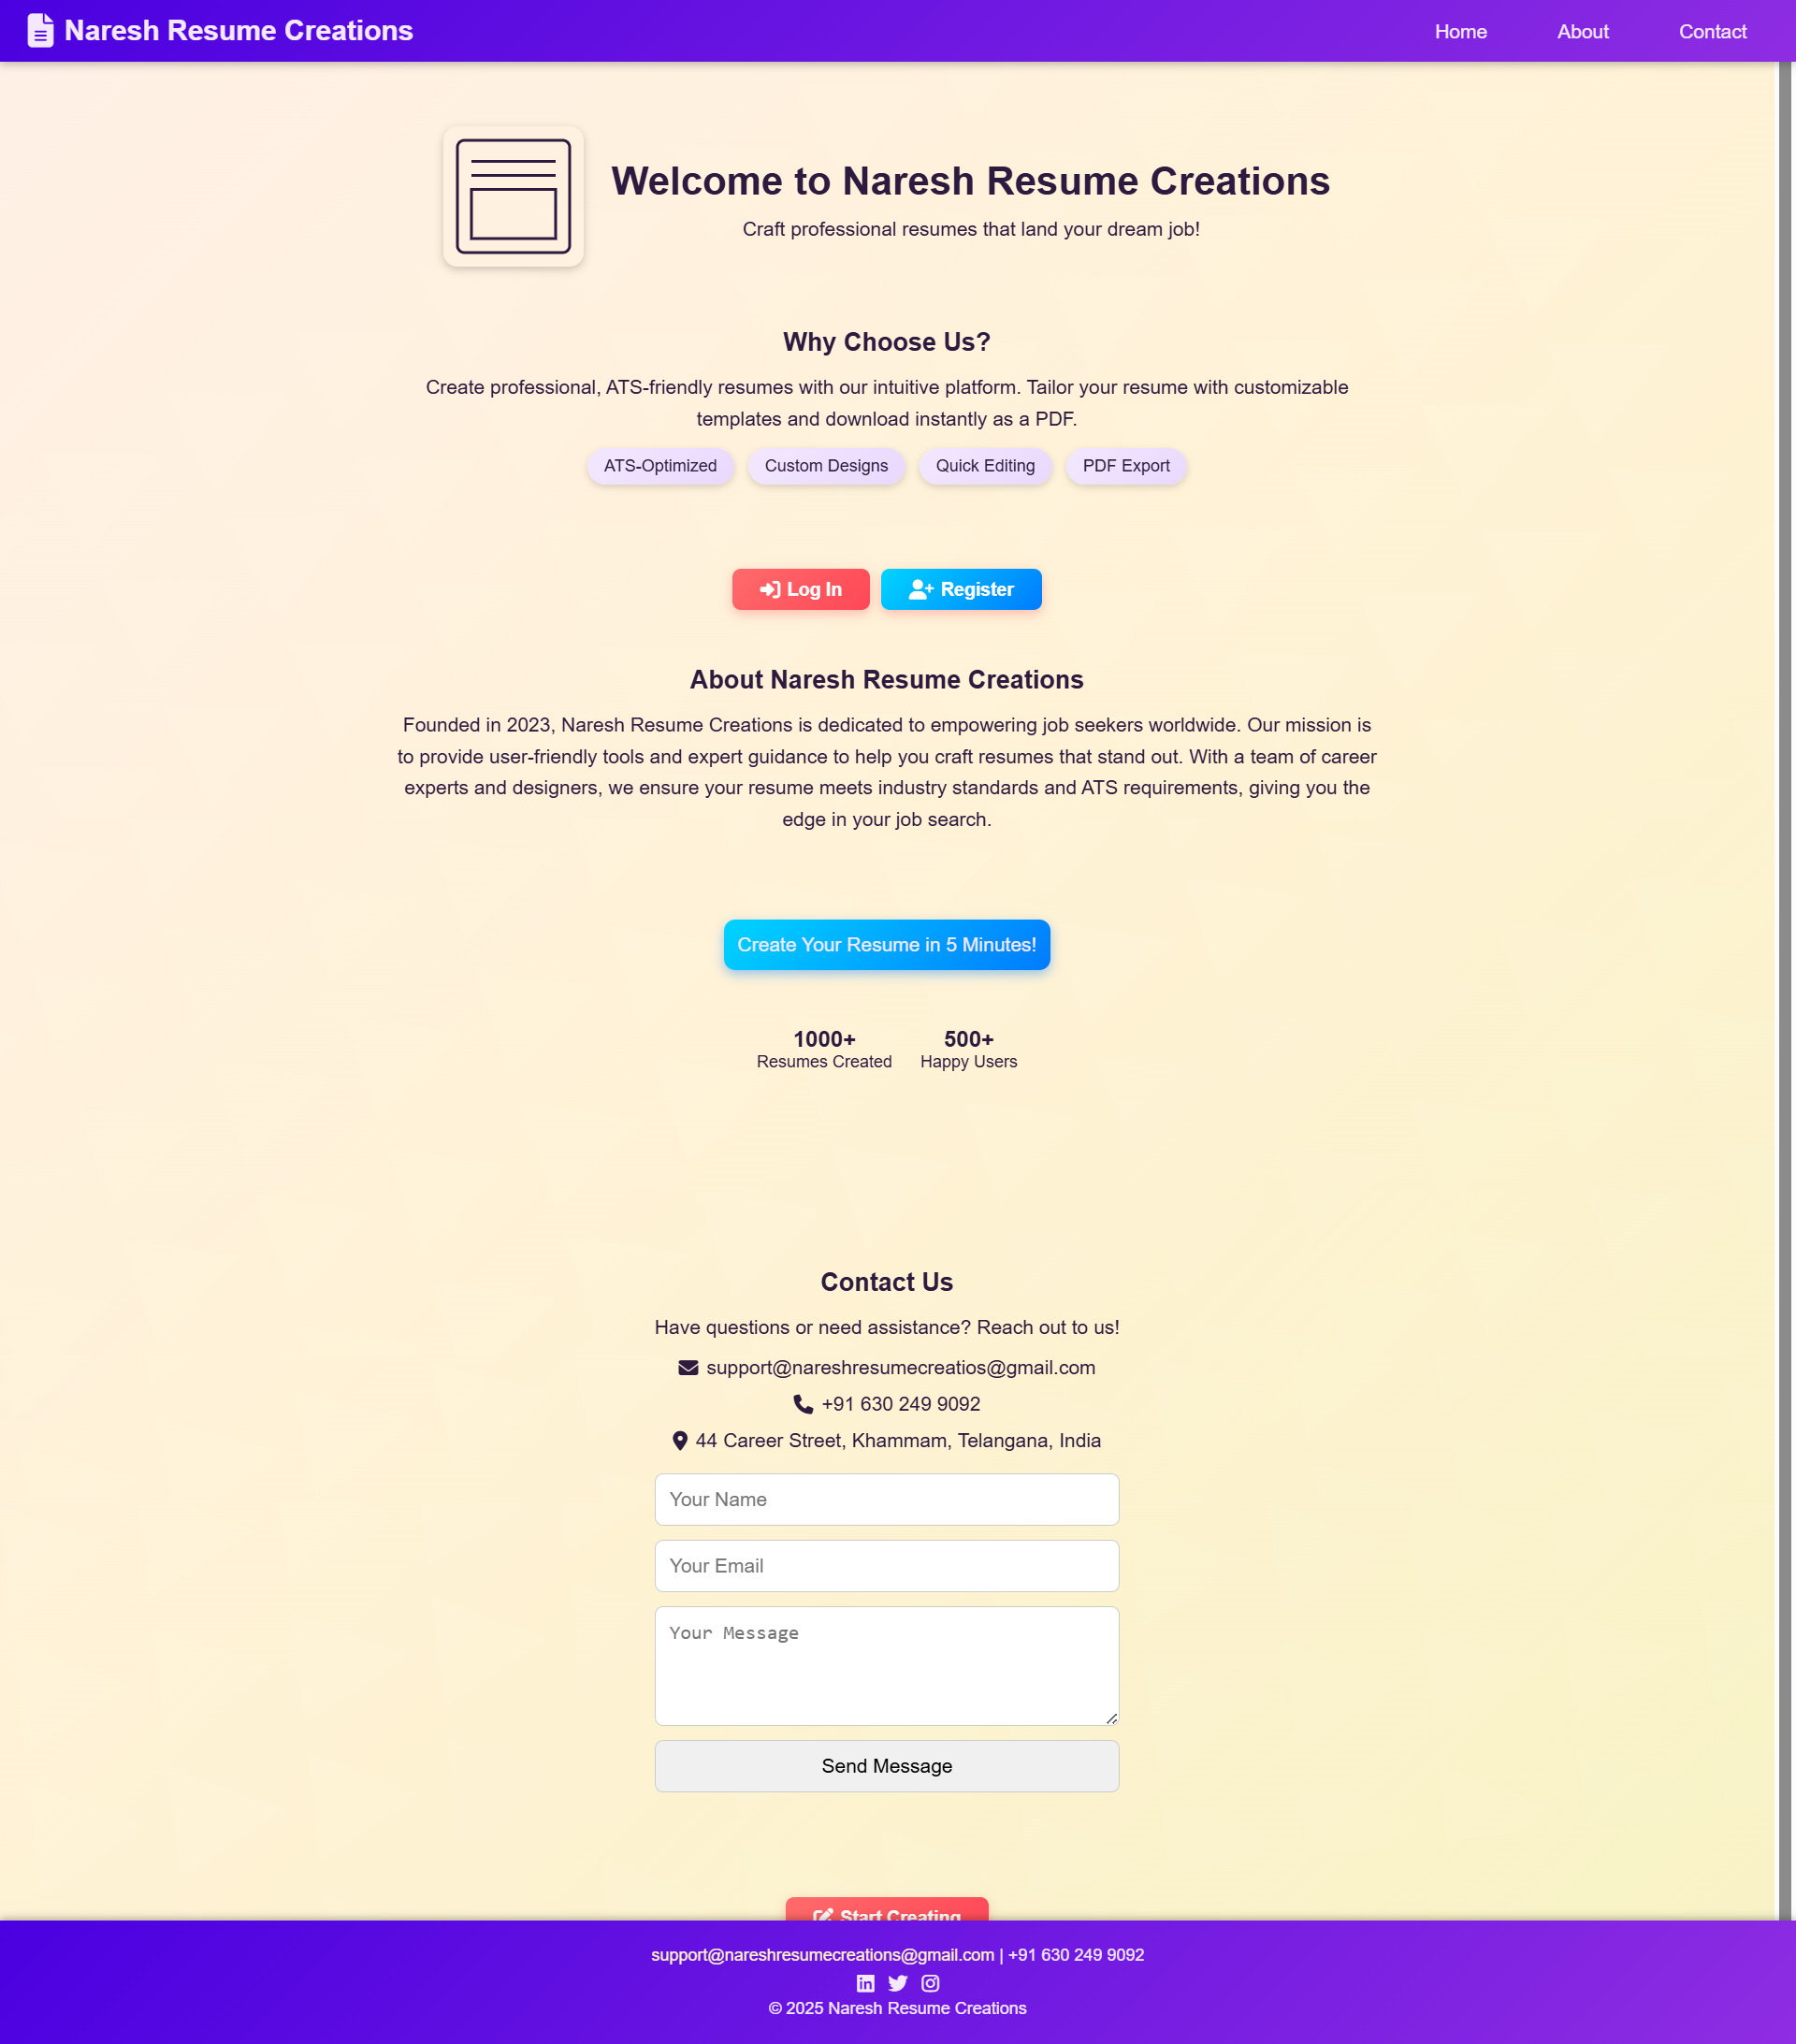**Welcome Page:**

The above screenshot is a **Welcome Page or Home Page** contains Login, Registration, About, Contact.

Below Image is about **User Registration** to create a User ID and Password

through Email.

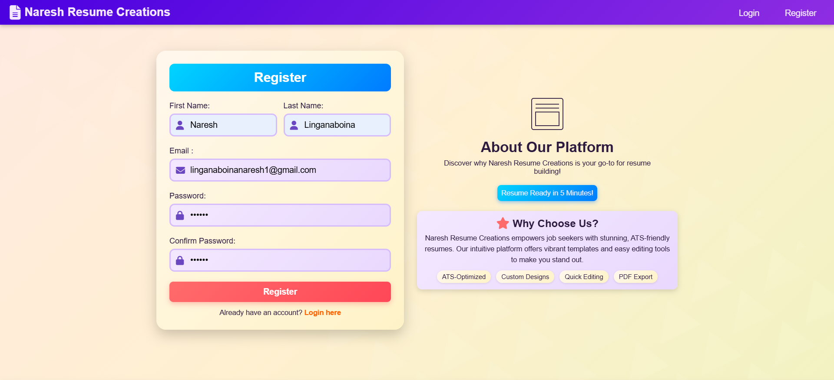

After completion of **Registration** user need to **Login** into the **Create Resume** Section.

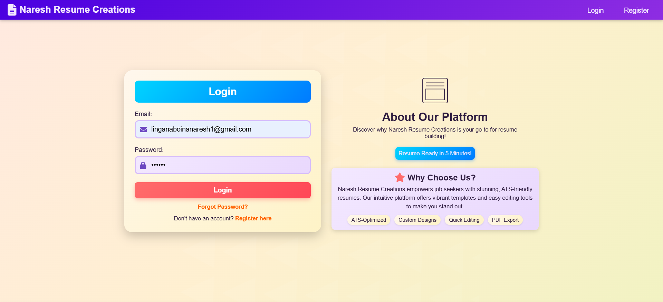

After Login, User enter into the create Resume section and enter the Personal Details, Employment History, Education, Skills, Internships, Courses, Languages, Hobbies, Custom Selection.

Below image is about Create Resume or Input Resume section. User enter the Details for Resume.

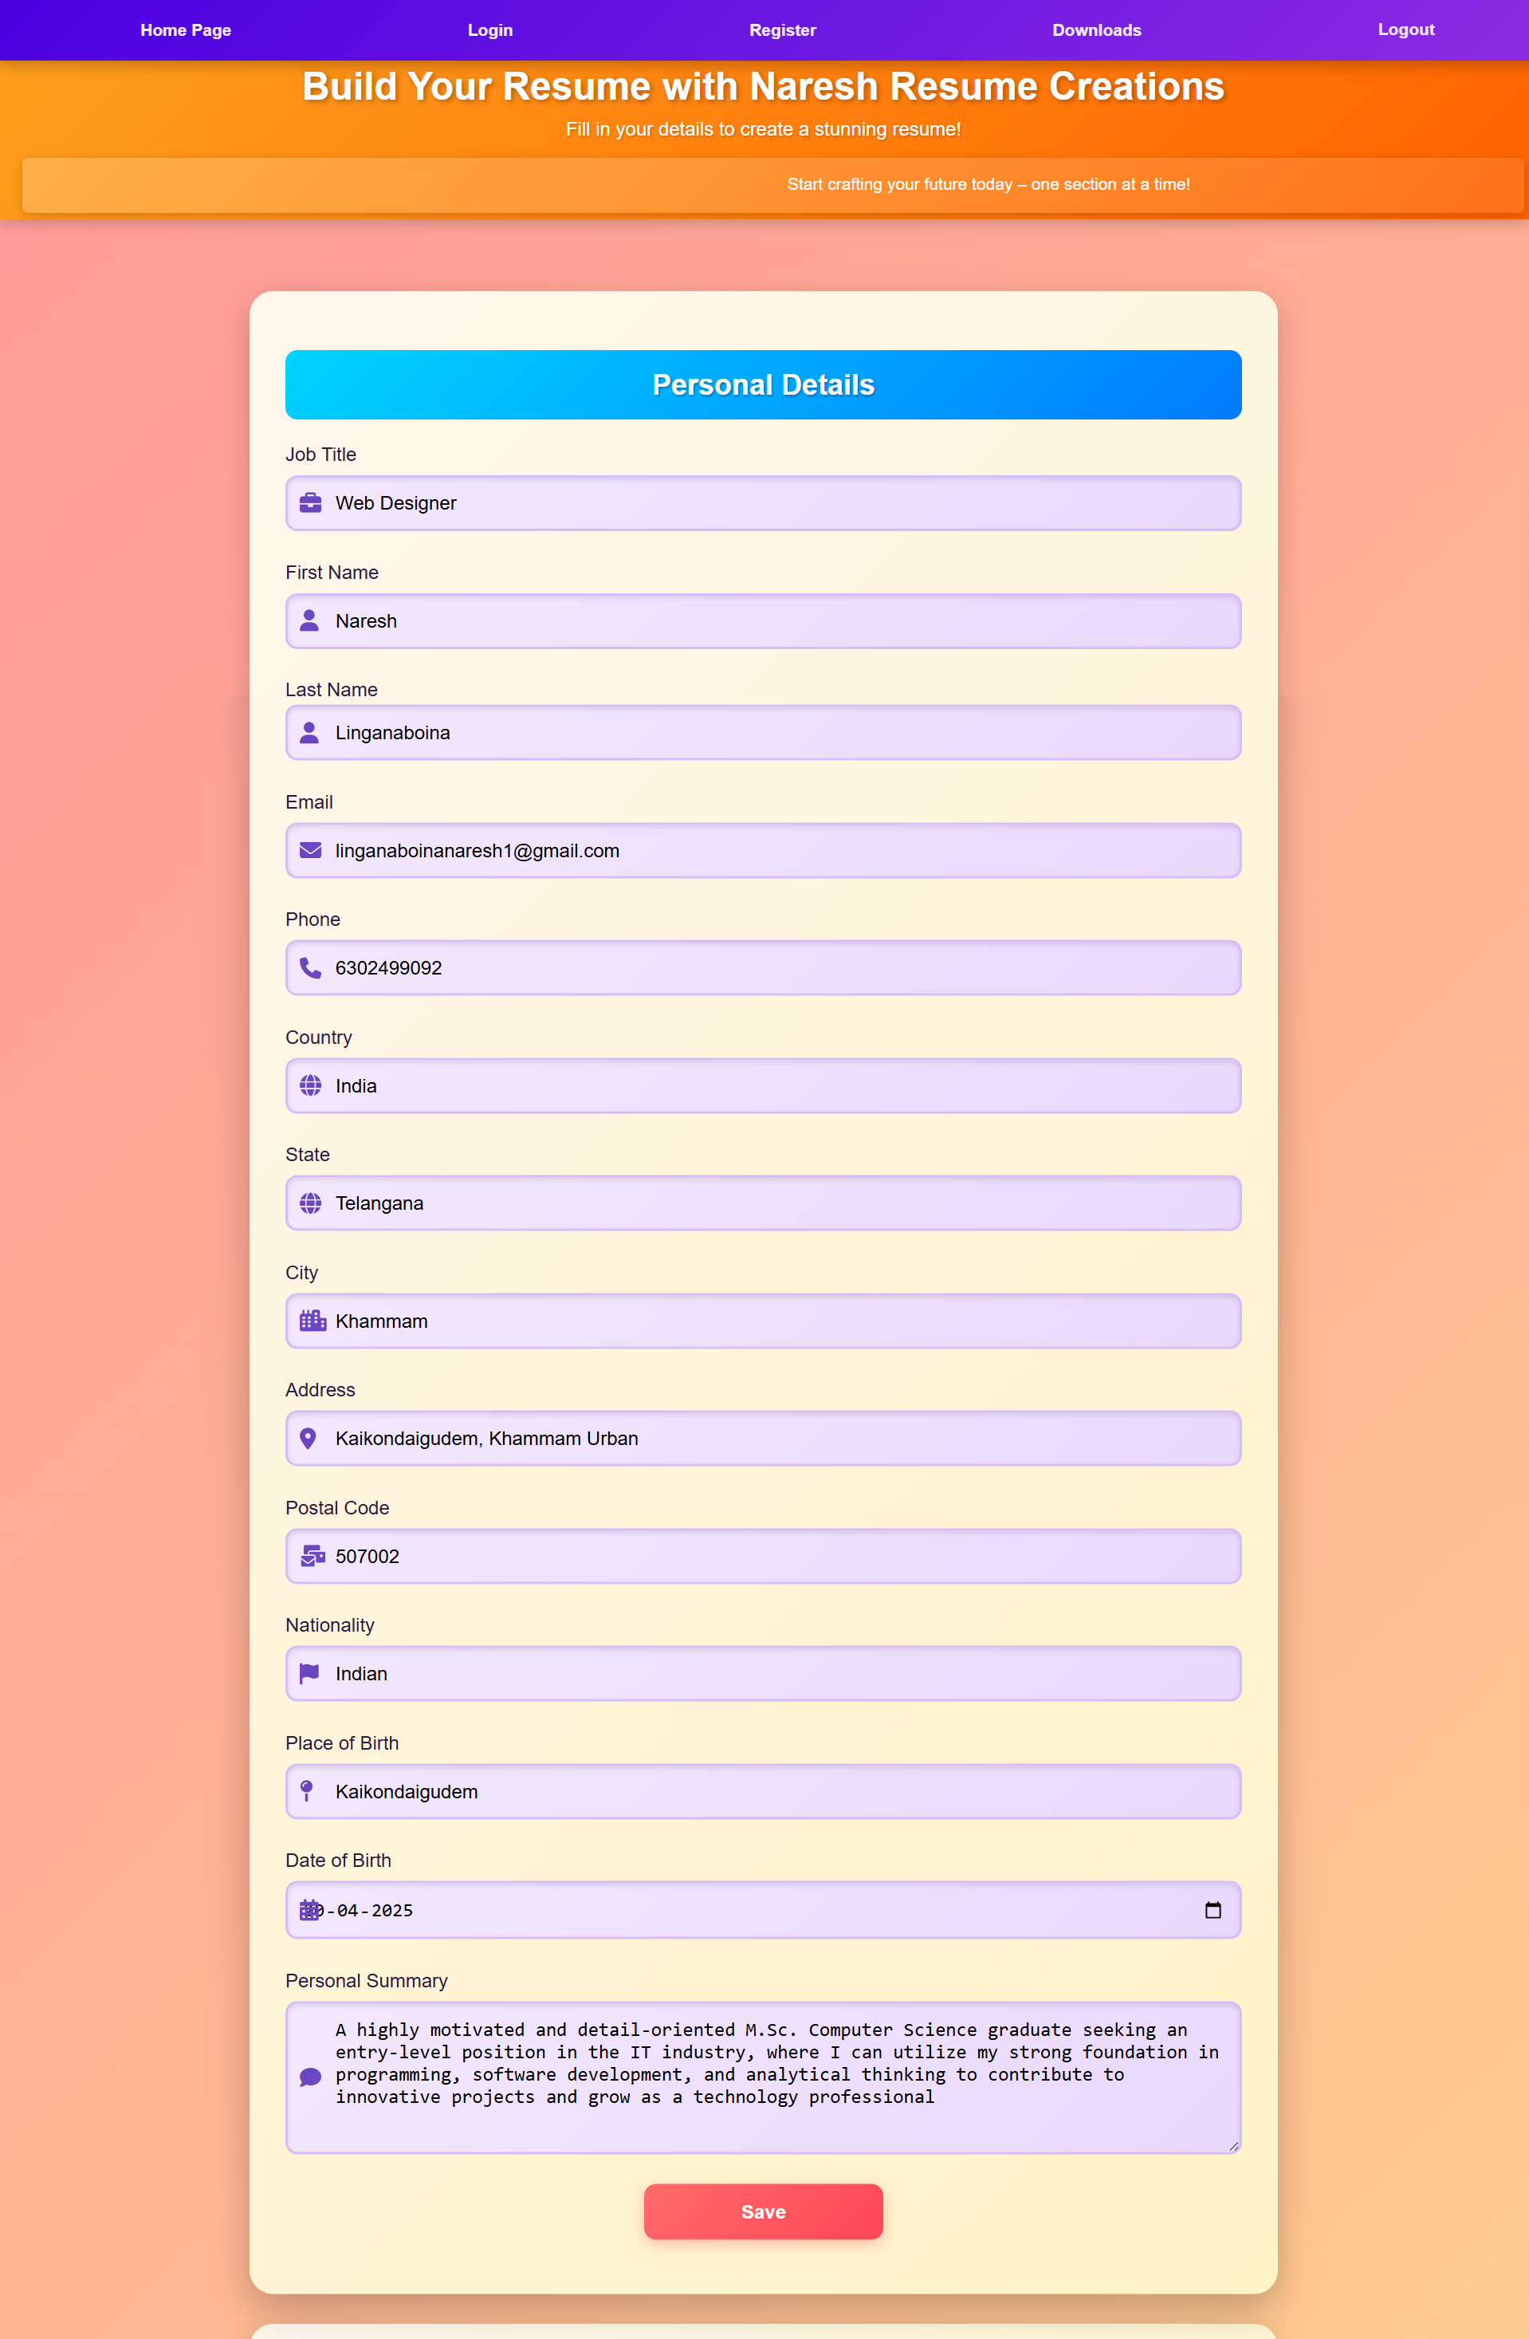

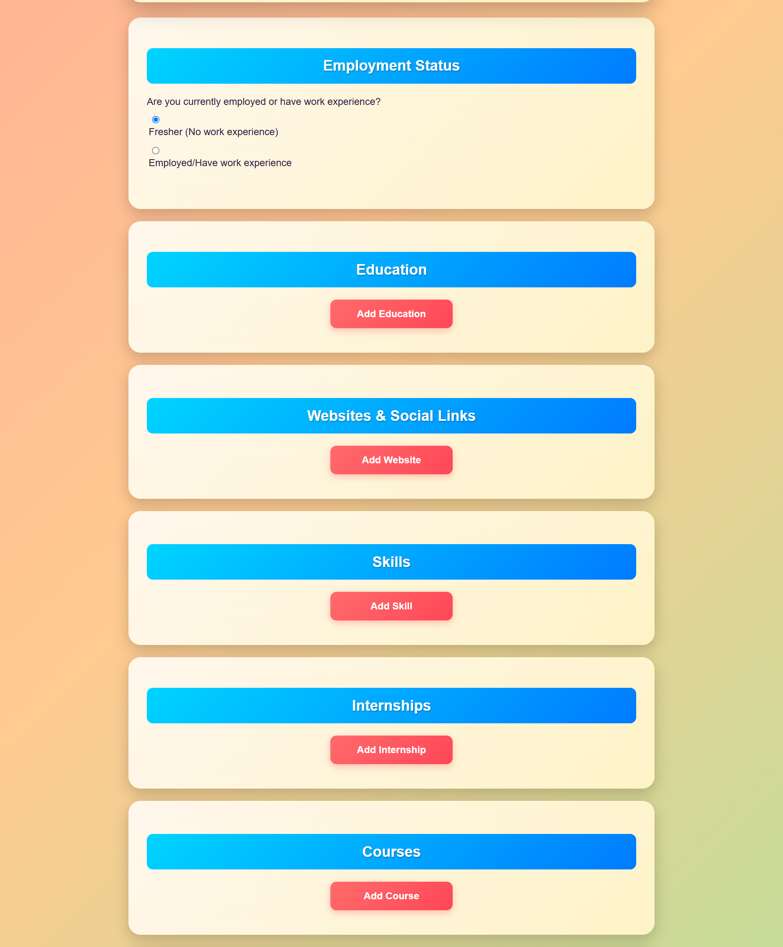

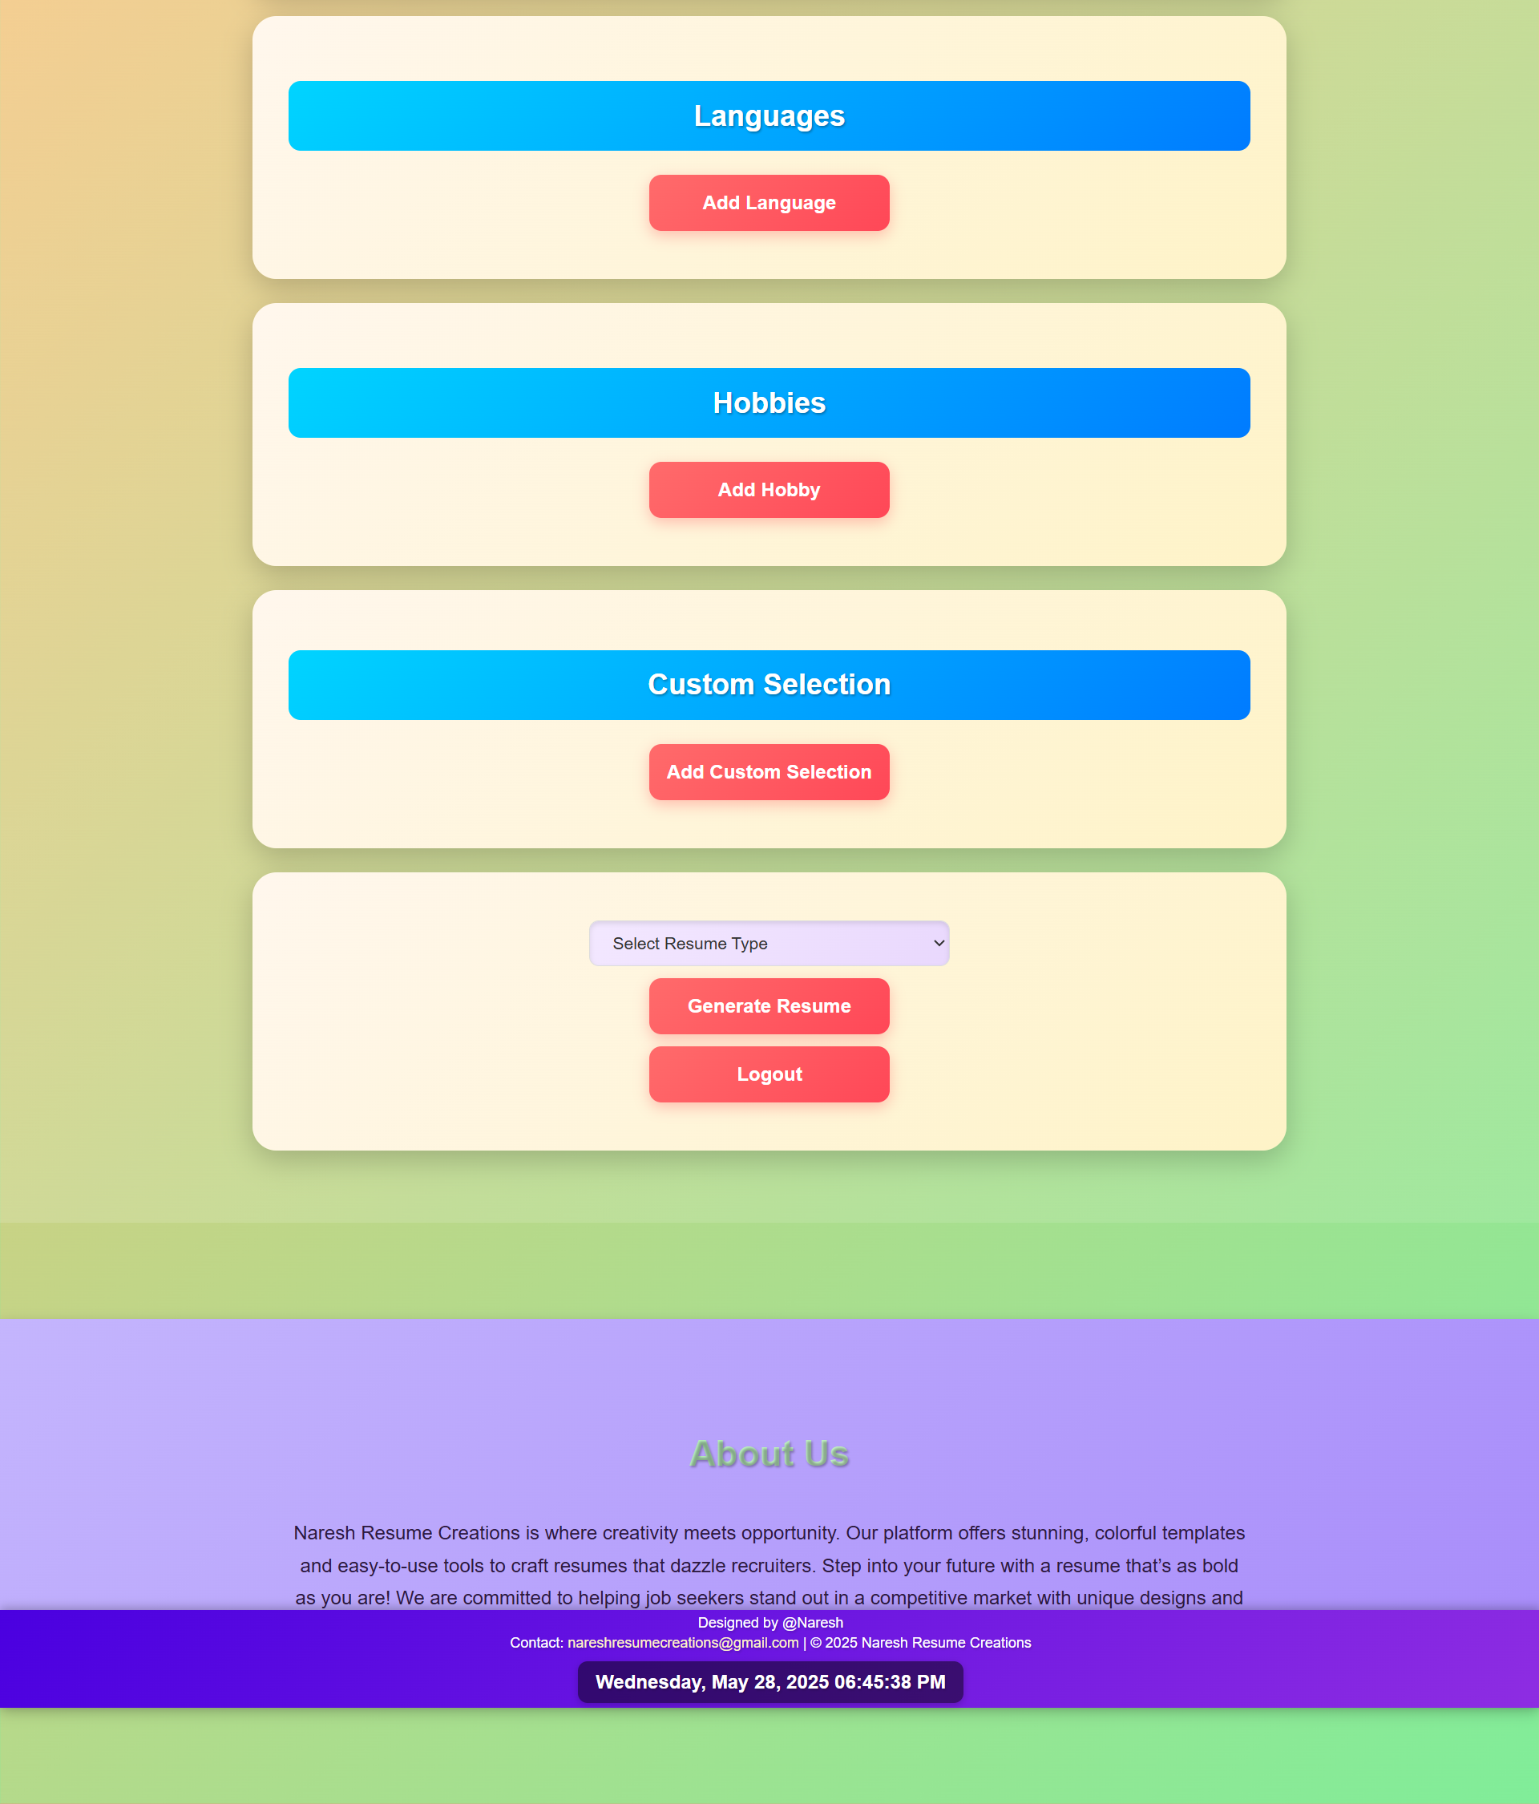

After User Enter all the Details and **Select Resume Template and Generate Resume**

to Showing Resume Full Template as shown in Below Image.

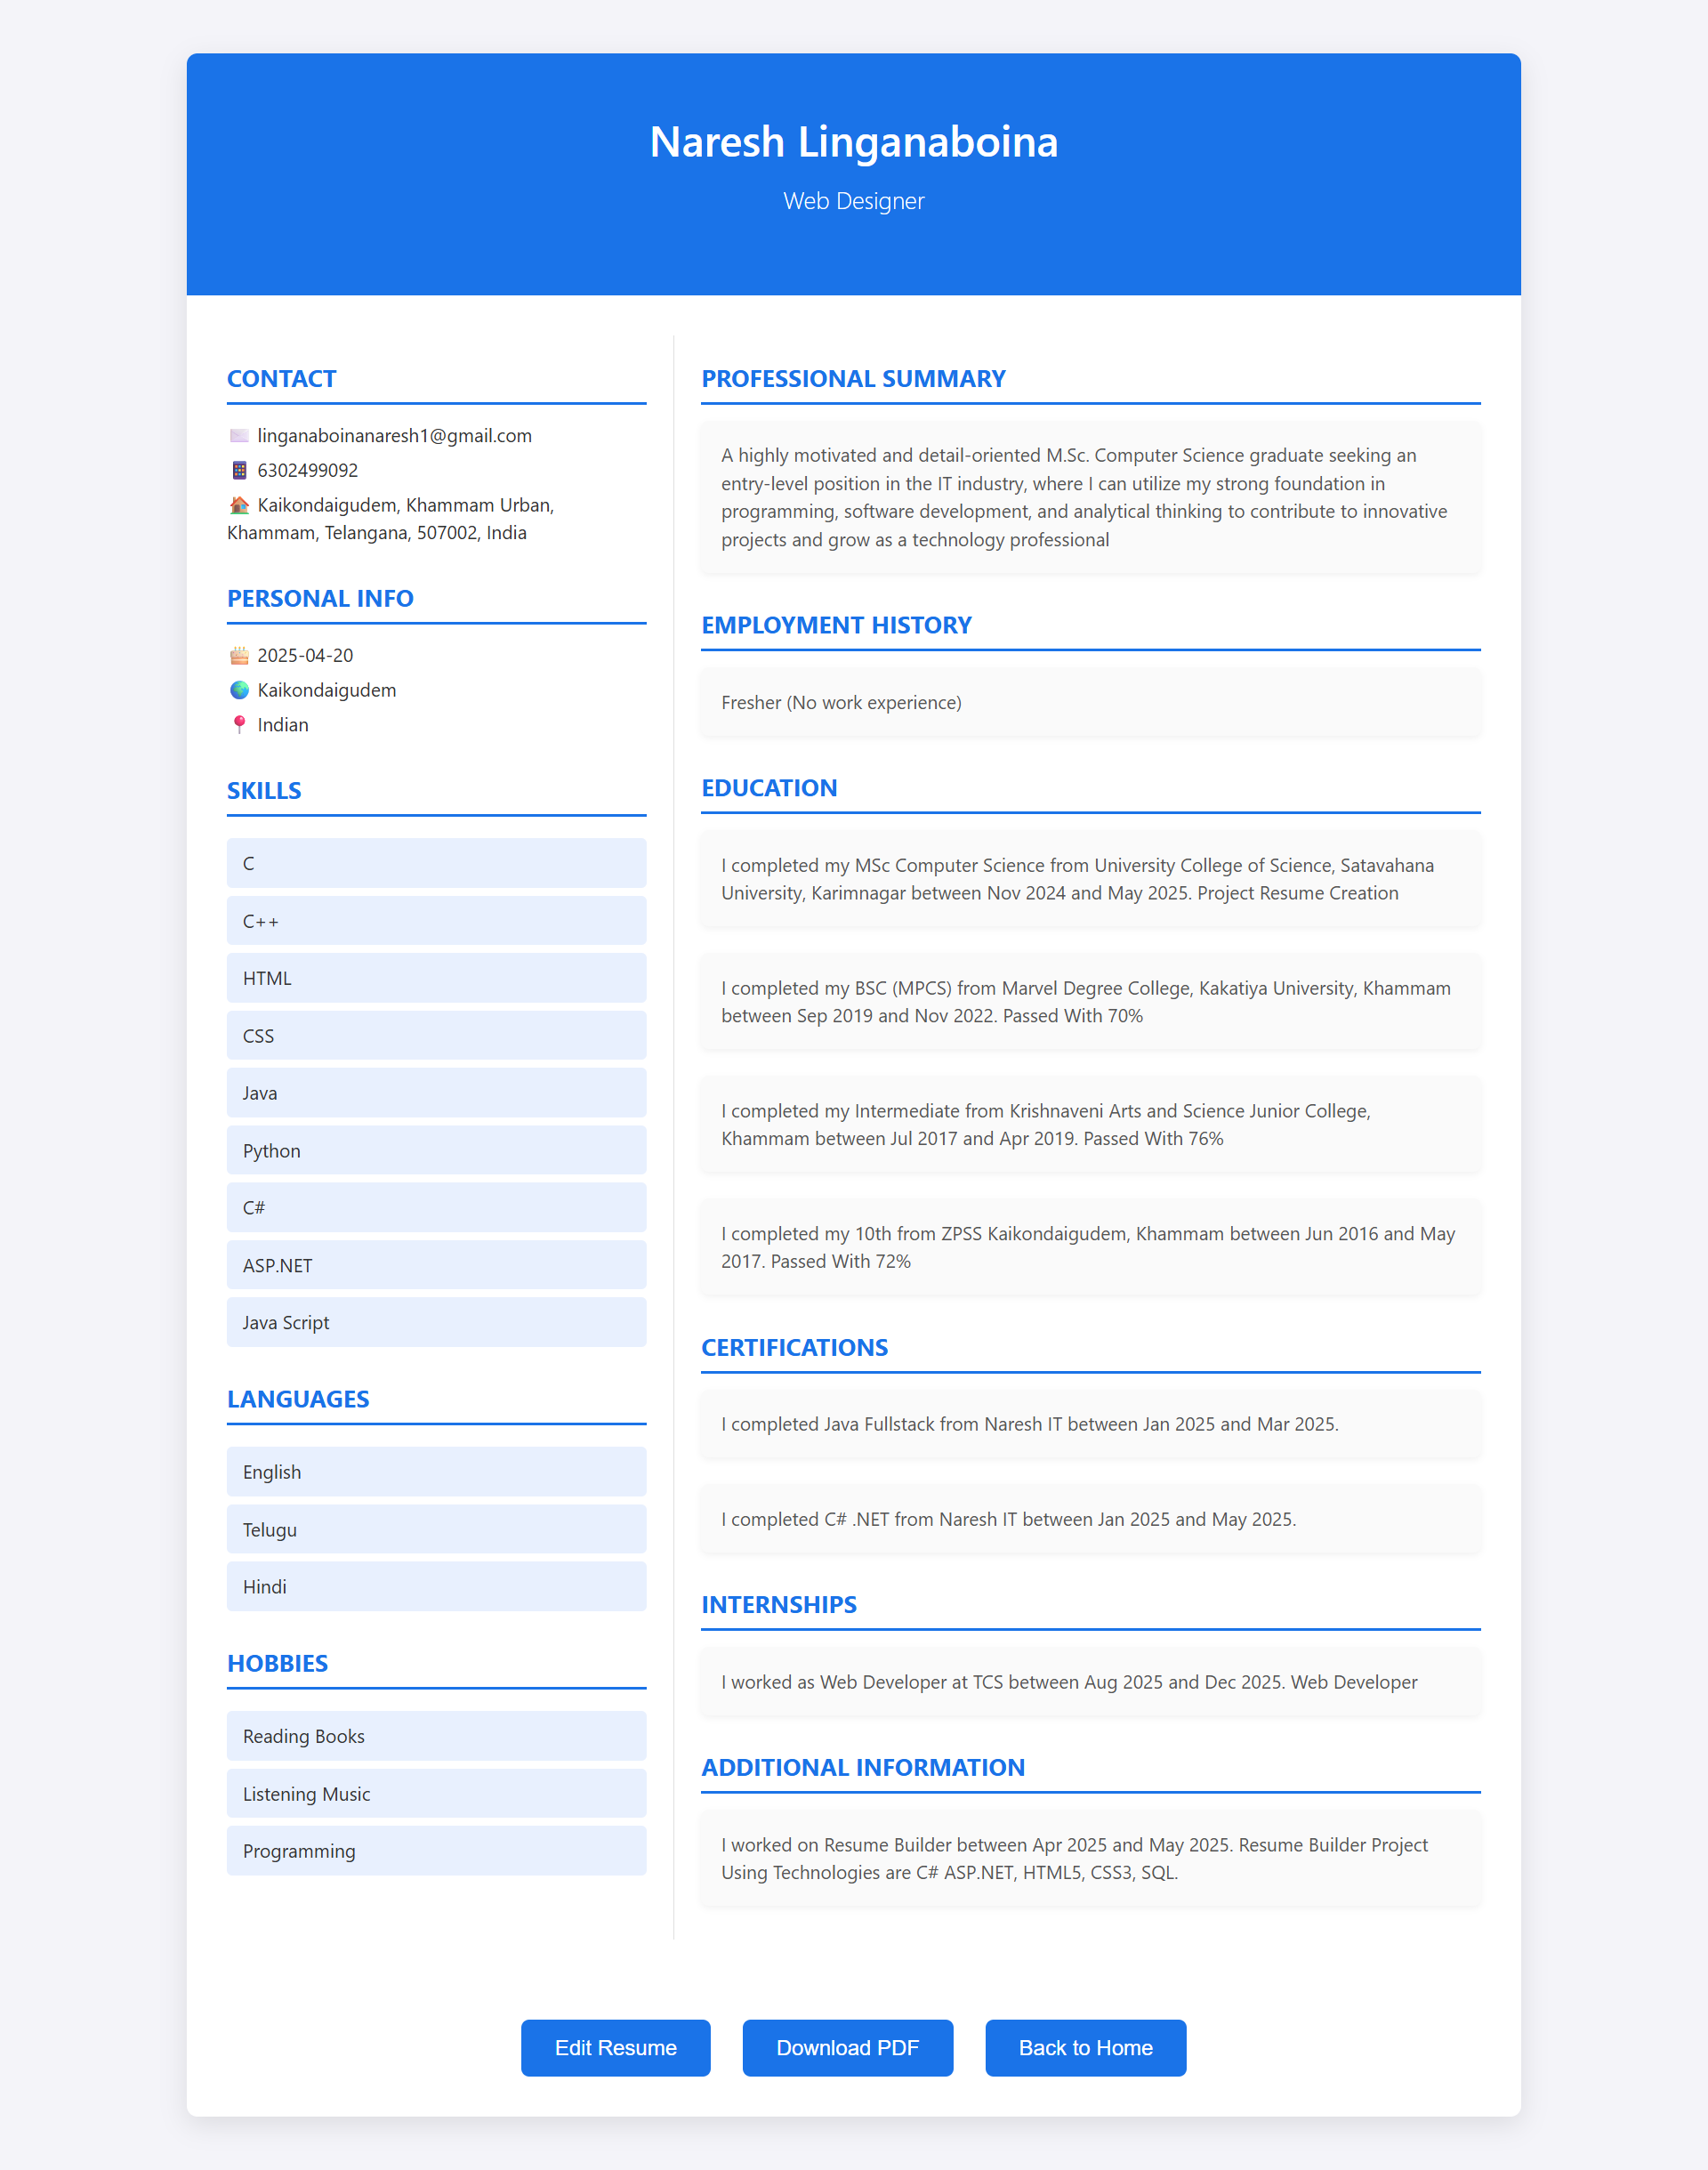

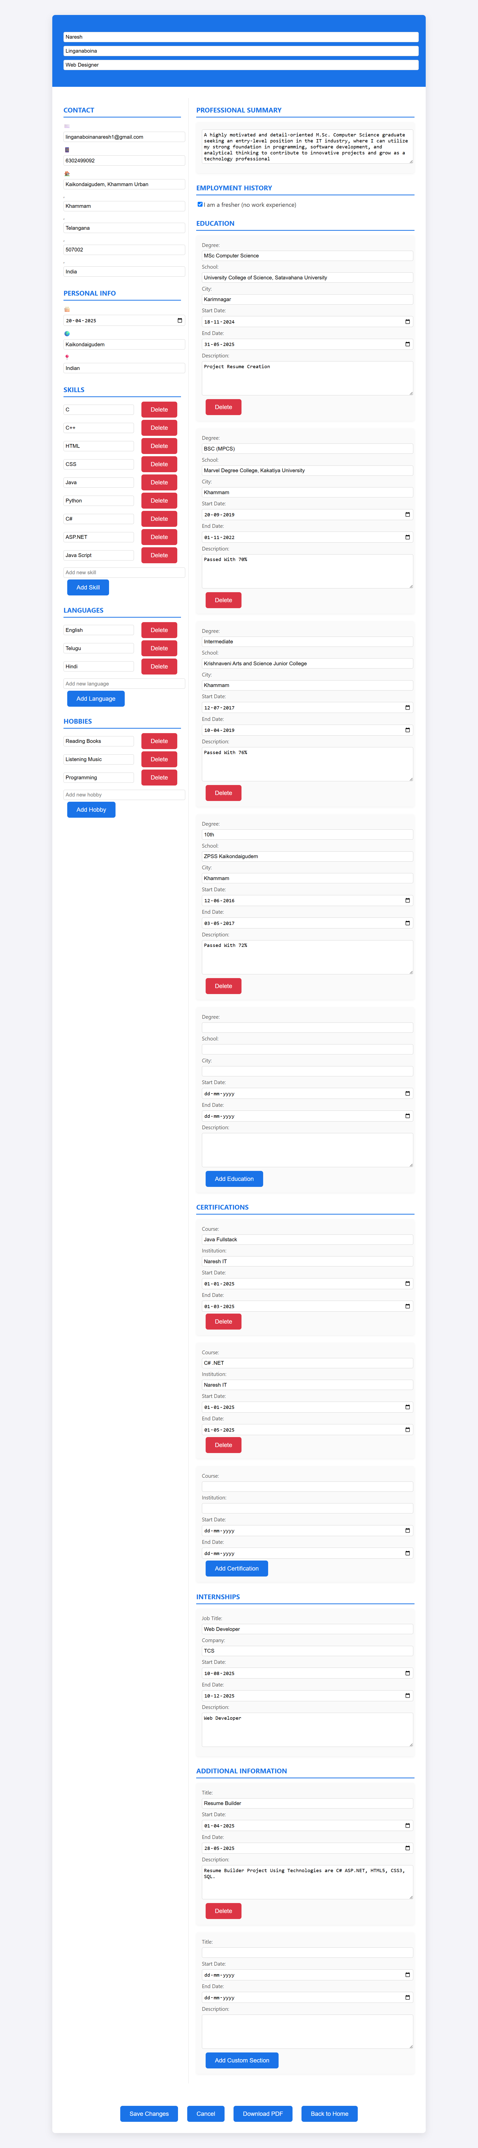 User In Resume Template if any mistakes to Click **Edit Resume.**

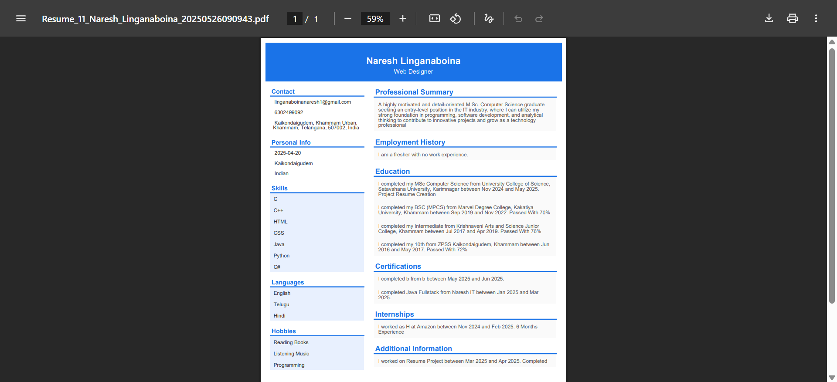 In **Resume Template** or **Edit Resume** Section, Download Pdf to Generate PDF

After User Login to show **Dashboard Page.** In Dashboard page Downloads section.

Download If user Download PDF previous to see **Downloads** section list of

downloaded PDF’s

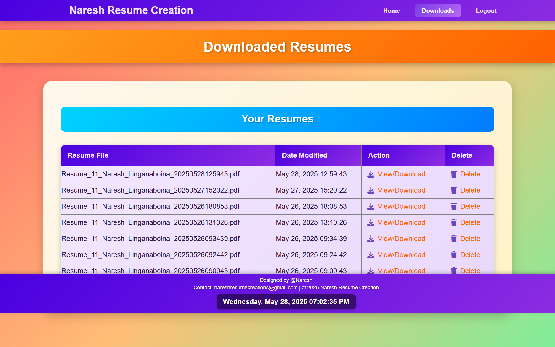

**12. TESTING**

Testing is a critical phase in the development of the Resume Builder system, built using C#, ASP.NET WebForms and SQL Server Management Studio (SSMS). It ensures the application functions as intended, meets user requirements, and is robust, secure, and performant. Below is an overview of testing strategies tailored for the Resume Builder project.

**Types of Tests**

**1. Unit Testing**

* **Purpose**: Test individual components (e.g., methods, classes) of the Resume Builder in isolation to ensure they function correctly.
* **Implementation**:
  + Use C# unit testing frameworks like **MSTest**, **NUnit**, or **xUnit** to write test cases for business logic, such as validating user input (e.g., email format, date ranges) or generating resume data.
  + Example: Test the Resume.GeneratePDF() method to ensure it correctly formats data into a PDF.
  + Use **Moq** or **NSubstitute** to mock dependencies, such as database access or external services, to isolate units.
* **Test Cases**:
  + Verify email validation logic rejects invalid formats.
  + Test date validation for education and work experience (e.g., end date after start date).
  + Check resume template rendering with sample data.
* **Tools**: Visual Studio Test Explorer, MSTest, Moq.

**2. Integration Testing**

* **Purpose**: Validate interactions between components, such as ASP.NET WebForms pages, C# backend logic, and SQL Server database.
* **Implementation**:
  + Test data flow between WebForms (e.g., PersonalDetails.aspx to Education.aspx) and the SQL Server database via ADO.NET or Entity Framework.
  + Example: Ensure user input from a WebForm is correctly saved to the database and retrieved for resume generation.
  + Use **Microsoft.AspNetCore.Mvc.Testing** (if applicable) or custom test harnesses to simulate HTTP requests and test server-side logic.
  + Set up a test database in SSMS to avoid affecting production data.
* **Test Cases**:
  + Verify saving a resume to the database and retrieving it for editing.
  + Test database connectivity and CRUD operations (Create, Read, Update, Delete).
  + Ensure session state persists across multi-step form submissions.
* **Tools**: MSTest, Entity Framework, SSMS, SQL Server Test Database.

**3. System Testing**

* **Purpose**: Evaluate the Resume Builder as a complete system to ensure it meets functional and non-functional requirements.
* **Implementation**:
  + Test the end-to-end workflow, from user input to resume generation and download.
  + Use **Selenium WebDriver** with C# to automate browser-based testing of WebForms, simulating user interactions like filling forms and downloading resumes.
  + Test compatibility across browsers (e.g., Chrome, Edge, Firefox).
* **Test Cases**:
  + Create a resume with all sections (personal details, education, experience, skills) and verify the output matches the selected template.
  + Test resume download functionality (e.g., PDF format).
  + Validate error handling for invalid inputs or database failures.
* **Tools**: Selenium WebDriver, BrowserStack (for cross-browser testing), Visual Studio.

**4. Acceptance Testing**

* **Purpose**: Ensure the Resume Builder meets user expectations and business requirements.
* **Implementation**:
  + Conduct **User Acceptance Testing (UAT)** with stakeholders or end-users to validate usability and functionality.
  + Example: Users create a resume, review the output, and confirm it meets their needs (e.g., professional formatting, accurate data).
  + Optionally, use **SpecFlow** with C# to write behavior-driven development (BDD) tests based on user stories.
* **Test Cases**:
  + Verify users can complete the resume-building process without errors.
  + Confirm the resume is visually appealing and downloadable in the expected format.
  + Validate accessibility features (e.g., screen reader compatibility).
* **Tools**: Manual UAT, SpecFlow, Selenium.

**5. Continuous Integration and Continuous Testing**

* **Purpose**: Automate testing to catch issues early and ensure code quality with every change.
* **Implementation**:
  + Set up a **CI/CD pipeline** using tools like **Azure DevOps**, **Jenkins**, or **GitHub Actions** to run unit and integration tests automatically on code commits.
  + Integrate test results into the build process to provide immediate feedback to developers.
  + Deploy to a staging environment for system testing after passing CI tests.
* **Test Cases**:
  + Run all unit and integration tests on each commit.
  + Trigger system tests on successful builds.
* **Tools**: Azure DevOps, Jenkins, MSBuild.

**6. Performance Testing**

* **Purpose**: Assess the Resume Builder’s responsiveness, scalability, and reliability under load.
* **Implementation**:
  + Use **Apache JMeter** or **k6** to simulate multiple users creating resumes simultaneously.
  + Test database performance under heavy load (e.g., multiple concurrent resume saves).
  + Profile the application using Visual Studio’s **Performance Profiler** to identify bottlenecks.
* **Test Cases**:
  + Measure response time for form submissions and resume generation.
  + Test system behavior with 100 concurrent users.
  + Verify database query performance for large datasets.
* **Tools**: JMeter, Visual Studio Performance Profiler, SQL Server Profiler.

**7. Security Testing**

* **Purpose**: Ensure the Resume Builder is secure against common vulnerabilities, protecting user data.
* **Implementation**:
  + Test for vulnerabilities like **SQL injection**, **cross-site scripting (XSS)**, and **cross-site request forgery (CSRF)** using tools like **OWASP ZAP** or **Burp Suite**.
  + Validate ASP.NET WebForms’ built-in security features, such as input validation and forms authentication.
  + Ensure sensitive data (e.g., user email, resume details) is encrypted in the database and during transmission (using HTTPS).
* **Test Cases**:
  + Attempt SQL injection on form inputs and verify no unauthorized access.
  + Test for XSS by injecting malicious scripts into form fields.
  + Verify role-based access control (e.g., users can only edit their own resumes).
* **Tools**: OWASP ZAP, Burp Suite, SQL Server Encryption.

**Testing Workflow**

1. **Plan**: Define test cases based on requirements and user stories for the Resume Builder.
2. **Develop**: Write automated tests (unit, integration, system) using C# and relevant frameworks.
3. **Execute**: Run tests locally during development and in the CI pipeline for every code change.
4. **Monitor**: Analyze test results, log failures, and fix issues promptly.
5. **Iterate**: Update tests as new features are added or requirements change.
6. **Deploy**: Perform final system and acceptance testing in a staging environment before production deployment.

**Expected Outcomes**

* **Reliability**: The Resume Builder consistently generates accurate and professional resumes.
* **Usability**: Users can easily navigate forms and complete the resume-building process.
* **Performance**: The system handles expected user loads without delays or crashes.
* **Security**: User data is protected against unauthorized access and attacks.
* **Maintainability**: Automated tests ensure new changes do not introduce regressions.

By implementing these testing practices, the Resume Builder will achieve high quality, reliability, and user satisfaction, delivering a robust and secure web application.

**13.CONCLUSION**

In conclusion, developing a Resume Builder using C#, ASP.NET WebForms, and SQL Server Management Studio (SSMS) offers a powerful opportunity to create a user-friendly, robust, and scalable solution that empowers users to create professional resumes with ease. By leveraging C#'s strong typing and object-oriented programming capabilities, ASP.NET WebForms' event-driven model and rich server controls, and SSMS's efficient database management, the system delivers a seamless experience for collecting, organizing, and presenting resume data.

The implementation of a well-structured algorithm ensures effective data collection, validation, and storage, enabling users to input personal details, education, work experience, and skills effortlessly while generating polished resumes in various formats. Comprehensive testing methodologies, including unit testing, integration testing, system testing, and security testing, validate the application's functionality, performance, and resilience, ensuring a high-quality and secure user experience.

By incorporating user feedback, robust error handling, and continuous optimization, the Resume Builder can be tailored to meet diverse user needs, such as customizable templates or integration with job portals. Adhering to best practices in software development and leveraging the mature .NET ecosystem, this system provides a reliable, maintainable, and efficient solution that enhances the accessibility and professionalism of resume creation for users across industries.

**14. BIBLIOGRAPHY**

The following bibliography includes references to books, documentation, online resources, and other materials that provide valuable information for developing a Resume Builder system using ASP.NET WebForms with SQL Server Management Studio.

1. **Wrox. "Professional ASP.NET 4.5 in C# and VB." Wiley, 2013.**
   * This book offers a comprehensive guide to ASP.NET, including WebForms, covering key concepts like server controls, state management, and database integration. It serves as a foundational resource for building the Resume Builder’s web interface and backend logic.
2. **Esposito, Dino. "Programming Microsoft ASP.NET 4." Microsoft Press, 2011.**
   * A detailed resource on ASP.NET, this book provides insights into WebForms development, including best practices for creating dynamic, data-driven web applications like the Resume Builder.
3. **Freeman, Adam. "Pro ASP.NET Core MVC 2." Apress, 2017.**
   * While focused on ASP.NET Core MVC, this book provides useful context for understanding ASP.NET’s evolution and modern web development practices, which can inform the design of scalable and maintainable features in the Resume **Builder.**
4. **Murach, Joel, and Anne Boehm. "Murach's ADO.NET 4 Database Programming with C# 2010." Mike Murach & Associates, 2011.**
   * This book covers ADO.NET for database programming in C#, offering practical guidance on connecting ASP.NET applications to SQL Server, a critical aspect of the Resume Builder’s data storage and retrieval.
5. **Kalani, Amit, and Deitel, Paul. "SQL Server 2012 with SSMS: A Step-by-Step Approach." McGraw-Hill Education, 2013.**
   * A beginner-friendly guide to SQL Server Management Studio (SSMS), this book provides tutorials on designing databases, writing queries, and managing data, which are essential for implementing the Resume Builder’s database.
6. **Gamma, Erich, et al. "Design Patterns: Elements of Reusable Object-Oriented Software." Addison-Wesley, 1994.**
   * This classic book introduces design patterns that can be applied to structure the Resume Builder’s architecture, ensuring modularity, scalability, and maintainability.
7. **Microsoft Documentation. "ASP.NET Web Forms Documentation." Microsoft Docs.**
   * The official Microsoft documentation for ASP.NET WebForms includes guides, tutorials, and API references, providing authoritative information for developing the Resume Builder’s web interface and server-side logic.
8. **Microsoft Documentation. "SQL Server and SSMS Documentation." Microsoft Docs.**
   * Official documentation for SQL Server and SQL Server Management Studio offers detailed guidance on database design, query optimization, and management, crucial for the Resume Builder’s data persistence.
9. **Online Tutorials and Communities:**
   * Websites like **Stack Overflow**, **CodeProject**, and **C# Corner** provide tutorials, code snippets, and discussions on ASP.NET WebForms, SQL Server, and resume-building applications. These resources offer practical solutions and troubleshooting tips for the project.
10. **Open Source Projects and GitHub Repositories:**
    * Exploring open-source ASP.NET projects and GitHub repositories related to form-based applications or resume builders provides code examples, architectural insights, and best practices for developing the Resume Builder.

This bibliography combines foundational texts, official documentation, and practical online resources to support the development of the Resume Builder using ASP.NET WebForms with SQL Server Management Studio. Additional references may be included based on specific project requirements or advanced features

.